

**Chatbot to known individual prakriti(phenotype)**

Project Report

Submitted by

M.Pothulaiah-20221CSE0434

G. Karthik Reddy-20221CSE0187

Under the guidance of,

Mr. Tamilselvan T, Assistant Professor

BACHELOR OF TECHNOLOGY

IN

COMPUTER SCIENCE AND ENGINEERING

PRESIDENCY UNIVERSITY

BENGALURU

NOVEMBER 2025



PRESIDENCY SCHOOL OF COMPUTER SCIENCE AND ENGINEERING

BONAFIDE CERTIFICATE

Certified that this report “Chatbot to known individual prakriti” is a Bonafide work of “Mallagundla Pothulaiah (20221CSE0434), Gangalakunta Karthik Reddy (20221CSE0187)”, who have successfully carried out the project work and submitted the report for partial fulfilment of the requirements for the award of the degree of BACHELOR OF TECHNOLOGY in COMPUTER SCIENCE ENGINEERING during 2025-26.

**Mr.Tamilselvan T** **Dr. Asif Mohammad Dr.Shakkeera L Dr.Duraipandian N**

Project Guide Head of the Department Associate Dean Dean

Presidency School Presidency School of Presidency School PSCS&PSIS

of Computer Science Computer Science of Computer Science Presidency

and Engineering and Engineering and Engineering University

Presidency University Presidency University Presidency University

Name and Signature of the Examiners

1)

2)



**PRESIDENCY UNIVERSITY**

**PRESIDENCY SCHOOL OF COMPUTER SCIENCE AND ENGINEERING**

DECLARATION

We the students of final year B. Tech in COMPUTER SCIENCE ENGINEERING at Presidency University, Bengaluru, named Mallagundla pothulaiah, Gangalakunta Karthik Reddy, hereby declare that the project work titled “Chatbot to known individual prakriti(phenotype)” has been independently carried out by us and submitted in partial fulfilment for the award of the degree of B. Tech in COMPUTER SCIENCE ENGINEERING during the academic year of 2025-26. Further, the matter embodied in the project has not been submitted previously by anybody for the award of any Degree or Diploma to any other institution.

MALLAGUNDLA POTHULAIAH 20221CSE0434 GANGALAKUNTA KARTHIK REDDY 20221CSE0187

PLACE: BENGALURU

DATE: DECEMBER 2025

**ACKNOWLEDGEMENT**

For completing this project work, We/I have received the support and guidance from many people whom I would like to mention with a deep sense of gratitude and indebtedness. We extend our gratitude to our beloved **Chancellor, Pro-Vice Chancellor, and Registrar** for their support and encouragement in the completion of the project.

I would like to sincerely thank my internal guide **Mr. Tamil Selvan T, Assistant Professor**, Presidency School of Computer Science and Engineering, Presidency University, for his moral support, motivation, timely guidance and encouragement provided to us during the period of our project work.

I am also thankful to **Dr. Asif Mohamed H B, Head of the Department, Presidency School of Computer Science and Engineering,** Presidency University, for his mentorship and encouragement.

We express our cordial thanks to **Dr. Duraipandian N**, Dean PSCS & PSIS, **Dr. Shakkeera L**, Associate Dean, Presidency School of Computer Science and Engineering and the Management of Presidency University for providing the required facilities and intellectually stimulating environment that aided in the completion of my project work.

We are grateful to **Dr Sampath A K and Dr Geetha A, PSCS** Project Coordinators**, Dr. Jayavadivel Ravi, Program Project Coordinator**, Presidency School of Computer Science and Engineering, for facilitating problem statements, coordinating reviews, monitoring progress, and providing their valuable support and guidance.

We are also grateful to the Teaching and Non-Teaching staff of Presidency School of Computer Science and Engineering, and also staff from other departments who have extended their valuable help and cooperation.

MALLAGUNDLA POTHULAIAH

GANGALAKUNTA KARTHIK REDDY

**Abstract**

Accurately​‍​‌‍​‍‌​‍​‌‍​‍‌ recognizing an individual’s Prakriti (phenotype) is central to Ayurvedic diagnosis, personalized treatment, and overall well-being. With preventive and integrative healthcare gaining more attention, there is a compelling demand for a systematic, easy-to-access, and standardized method for determining Prakriti. A well-organized framework that looks at one's physical, physiological, and psychological characteristics can open a clear and simple-to-understand platform for explaining the constitution of Vata, Pitta, and Kapha.

The designed chatbot uses a simplified and resourceful procedure to gather information from a user, examine the answers, and create a customized Prakriti report. The program collects the information needed through a friendly conversation with a user; then it interprets the characteristics given and delivers valuable insights related to the constituent profile to the user. By adhering to a standard evaluation process, the chatbot maintains precision, impartiality, and stability of the results while at the same time, it lessens the influence of subjective views and thereby helps the practitioners in making well-informed, accurate, and consistent diagnostic decisions.

As more and more digital wellness tools are becoming available, the point of doing Prakriti with accuracy and uniformity becomes quite obvious. This chatbot meets that condition by providing a digitally organized platform that eases the constitution assessment process and at the same time maintains both scientific and Ayurvedic rigor.

The questions the system is using to gather information are physically, temper mentally, metabolically, behaviourally, and environmentally. The system follows Ayurvedic principles to decide if a person is mainly Vata, Pitta, or Kapha or a mixture of doshas. In order to enhance the dependability of the given answers, the chatbot also considers the links between digestion, sleep, emotional responses, body features, and lifestyle habits when it is analyzing these connected parts. Such a multi-layered evaluation helps identify one's Prakriti in a more holistic manner and less biased which matches fairly well with the traditional Ayurvedic understanding.

The chatbot, apart from being useful to general users, practitioners, also simplifies the process of easy communication, interpretation of findings, and drawing up reports that are brief yet cover all the important points. The scoring automation also contributes greatly to the fairness and clarity of the evaluation results.

**Table of Content**

|  |  |  |
| --- | --- | --- |
| **Sl. No.** | **Title** | **Page No.** |
|  | Declaration | III |
|  | Acknowledgement | IV - V |
|  | Abstract | VI |
|  | List of Figures | 1 |
|  | List of Tables | 2 |
|  | Abbreviations | 3 |
| 1. | Introduction  1.1 Background  1.2 Statistics of project  1.3 Prior existing technologies  1.4 Proposed approach  1.5 Objectives  1.6 SDGs  1.7 Overview of project report | 4-8 |
| 2. | Literature review | 9-12 |
| 3. | Methodology | 13-27 |
| 4. | Project management  4.1 Project timeline  4.2 Risk analysis  4.3 Project budget | 28-30 |
| 5. | Analysis and Design  5.1 Requirements  5.2 Block Diagram  5.3 System Flow Chart  5.4 Choosing devices  5.5 Designing units  5.6 Standards  5.7 Mapping with IoTWF reference model layers  5.8 Domain model specification  5.9 Communication model  5.10 IoT deployment level  5.11 Functional view  5.12 Mapping IoT deployment level with functional view  5.13 Operational view  5.14 Other Design | 31-44 |
| 6. | Hardware, Software and Simulation  6.1 Hardware  6.2 Software development tools  6.3 Software code  6.4 Simulation | 45-48 |
| 7. | Evaluation and Results  7.1 Test points  7.2 Test plan  7.3 Test result  7.4 Insights | 49-52 |
| 8. | Social, Legal, Ethical, Sustainability and Safety Aspects  8.1 Social aspects  8.2 Legal aspects  8.3 Ethical aspects  8.4 Sustainability aspects  8.5 Safety aspects | 53-55 |
| 9. | Conclusion | 56-59 |
|  | References | 60-65 |
|  | Base Paper | 65 |
|  | Appendix | 66-68 |

**List of Figures**

|  |  |  |
| --- | --- | --- |
| **Figure** | **Caption** | **Page no** |
| Fig 3.2.1 | The V-Model Methodology | 14 |
| Fig 3.4.1 | Workflow Overview | 17 |
| Fig 3.4.2 | Microservice System Architecture | 19 |
| Fig 3.4.3 | UML Class Diagram | 21 |
| Fig 3.4.4 | Public Safety AI Database ER Diagram | 24 |
| Fig 4.1 | Timeline of the Project (Gantt Chart Summary) | 28 |
| Fig 5.2.1 | Functional Block Diagram of the Feedback System | 34 |
| Fig 5.3.1 | System Flow Chart of Workflow | 35 |
| Fig 5.6.1 | Communication Model | 39 |
| Fig 7.3.1 | Anomaly Detection Alert for a Negative Feedback | 51 |

**List of Tables**

|  |  |  |
| --- | --- | --- |
| **Table** | **Caption** | **Page no** |
| Table 2.1.1 | Summary of Literature Reviews | 11 |
| Table 3.2.1 | Mapping V-Model to Project Stages | 14 |
| Table 3.4.1 | Comparison with Other Methodologies | 16 |
| Table 4.2.1 | Project Risk Analysis (General Risks) | 29 |
| Table 4.3.1 | Data-Related Risks | 30 |
| Table 5.9.1 | Mapping IoT Deployment Level With Functional View | 42 |
| Table 6.1.1 | System Hardware Requirements | 45 |
| Table 6.1.2 | System Software Requirements | 46 |

**Abbreviations**

|  |  |
| --- | --- |
| **Abbreviation** | **Full Form** |
| **AI** | Artificial Intelligence |
| **NLP** | Natural Language Processing |
| **ML** | Machine Learning |
| **DL** | Deep Learning |
| **ANN** | Artificial Neural Network |
| **SVM** | Support Vector Machine |
| **NB** | Naive Bayes |
| **RF** | Random Forest |
| **API** | Application Programming Interface |
| **HTTP** | HyperText Transfer Protocol |
| **SQL** | Structured Query Language |
| **B.Tech** | Bachelor of Technology |
| **CSE** | Computer Science and Engineering |
| **PSCS** | Presidency School of Computer Science and Engineering |
| **V** | Vata |
| **P** | Pitta |
| **K** | Kapha |
| **WS** | WebSocket |

**Chapter 1**

**Introduction**

Ayurveda is the holistic Indian traditional system of medicine. One of the main concepts of Ayurveda is Prakriti which means the unique permanent mental and physical constitution of an individual. This constitution is basically a balanced mixture of three primary biological energies (doshas) called Vata, Pitta, and Kapha.

According to the Ayurvedic system, knowing one's Prakriti is the key to health maintenance, disease prevention, and balance realization as it controls not only physical features and metabolic processes but also mental and emotional tendencies. Usually, the identification of Prakriti is a delicate work of an experienced Ayurvedic doctor thus it is a doctor&#39; specialized service which is not always easily ‍accessible.

**1.1 Background**

Ayurveda, ‍the science of life, is an ancient medical system from India, which is a holistic health model that considers the well-being of the entire person. The basic concept of Ayurveda is Prakriti, which describes a person's unique, indestructible triadic mental and physical nature of the universe derived from the origin of the cosmos. The idea is based on the equilibrium of the three ultimate biological energies or Doshas that make up the universe: Vata (made of air and space), Pitta (fire and water), and Kapha (earth and water). The physical, mental, and emotional traits of a human being are the particular combination of the three doshas in that person.

**1.2 Statistics**

The twenty-first century has led to drastic changes in the healthcare system. The main remedy one-size-fits-all models have been replaced mostly by preventive, personalized, and holistic wellness models, which have been in the focus at both the global and regional levels. One of the effects of such a trend is the return of global and regional interest in traditional medicine systems like Ayurveda, which are inherently personalized. The AyurBot project is a consequence of the wellness trend that is becoming more and more popular and, at the same time, the healthcare services are rapidly going digital, especially in the regional context of India.

**1.3 Prior existing technologies**

The AyurBot project is very ambitious and intends to change the digital health ecosystem, which is already very far-reaching and rapidly evolving, in a significant manner. While investigating the technologies previously implemented, various application categories have been recognized that have different kinds of relationships with this project. These technologies have facilitated the implementation of digital health interventions; however, they have at the same time demonstrated a clear technological and conceptual divide that this project aims to bridge. For that reason, the dominant category is one of the most general health and symptom-checker chatbots. The platform is a demonstrative example of AI conversational use, where the virtual assistant delivers a set of questions, the user answers them, and then the possible medical conditions are identified. Ada Health and Babylon Health have efficiently demonstrated this function of Conversational AI.

**1.4 Proposed approach**

Project aim: The first and foremost goal of the project is to come up with and carry out the idea of AyurBot, an intelligent conversational agent that can figure out a person's Ayurvedic Prakriti (mind-body constitution). The side goals also include supplying the users with diet and lifestyle recommendations that are in line with their Prakriti and making it easier for the fundamental concepts of Ayurveda to be known among the modern generation through an attractive digital platform.

Motivation: The main reason for this study is the worldwide trend of personalized, holistic, and preventative wellness. Also, the most personalized healthcare approach is proposed by Traditional systems like Ayurveda, though their principles could be very challenging for a beginner to understand the system. This project is borne out of the idea of employing AI as the link between ancient wisdom and modern tech-savvy people so that the end product is not just a user-friendly tool but also an educational one.

Proposed approach: The proposed solution is to be a full-stack web application with modern client-server architecture intended for instant interaction.

Frontend: A highly modifiable React and Vite powered single-page application (SPA). The user interface was developed with Tailwind CSS, which guarantees a responsive and user-friendly experience.

Backend: A creative Python-based asynchronous server that uses the FastAPI framework and is hosted on a Uvicorn ASGI server.

Communication: The initial communication between the user and the server is through HTTP, whereas the chat functionality is supported by a WebSocket connection, which enables real-time, two-way ‍ ‌‍ ‍interaction.

**Applications of the project:**

**‌A Personal Wellness Tool:**

The instrument can be a method of self-exploration by individuals in understanding their constitutional type and receiving practical health tips.

**An Educational Gateway**:

For beginners, it serves as a nice and interactive method of learning the fundamental principles of Ayurveda.

**Client Engagement for Practitioners**:

The Ayurvedic clinics may utilize the instrument as a medium of engagement by integrating it into their websites for attracting potential clients.

**Research Data**: Upon obtaining user consent, anonymized data may be made available for research purposes for discovering correlations between lifestyle patterns and Prakriti types.

**Limitation of the proposed approach:**

The chatbot is created to be informative and thus should not be considered as a substitute for professional medical advice. Its results are not a medical diagnosis and hence should not be used for the purpose of self-diagnosis or treatment of health conditions.

The accuracy of the AI models is entirely dependent on the quality and quantity of the training data. A minimal or biased dataset can lead to less accurate predictions of Prakriti.

The assessment is made based on the user's subjective input. The user's perception of themselves and their interpretation of the questions may influence the result, which is something a human practitioner might be able to handle more ‍‌effectively.

**Goals**

To develop and deploy a frontend of a reactive Single-Page Application (SPA) with React, that would maintain a WebSocket connection with a FastAPI backend to allow for real-time, two-way communication.

The first goal of the models was to be used as a Natural Language Processing (NLP) tool for the classification of user intent. The second model was to be designed to identify user Prakriti from a vectorized set of questionnaire answers. These two models were to be built and integrated as a machine learning pipeline in TensorFlow/Keras.

To create a fastAPI backend with a well session-based state management system so that the simultaneous user conversations can be followed individually without any data leakage.

To employ SQLAlchemy as a layer between the database and the app to monitor the conversation between users and also to record user Prakriti results and to implement a function that can be used to personalized diet and lifestyle recommendation reports in the form of PDF files for users.

**SDGs**

The primary purpose of the AyurBot project is to conform with the United Nations Sustainable Development Goal 3 (SDG 3): Good Health and Well-being, that aims at " the provision of healthy lives and the promotion of well-being for people of all ages." The project realizes this objective by supporting the health informatics application, i.e. the efficient acquisition, handling, and use of the data that lead to better health outcomes.

By Introducing and Facilitating Preventive Health and Well-being : Before anything else, AyurBot was only meant to serve the healthcare industry as a prevention-related tool. Through explaining the user's unique Ayurvedic Prakriti, the chatbot offers a personalized and scientific dietary and lifestyle guide for the users, which they can then follow.

**Project report overview**

The report is a detailed narrative of the development process of the AyurBot project starting from the conception and design stages and ending with the evaluation and final thoughts. First, there is an introductory section describing Ayurveda and Prakriti, the project's goals and the approach, the correlation of the project with UN SDGs, and a brief overview of the report itself. The second chapter is the literature review that presents a comprehensive review of research conducted in the fields of computational methods for Prakriti determination and health chatbot technologies. The next chapter introduces the research methodology, followed by Chapter 4 that describes the project management plan with the project timeline, risk analysis, and budget.The major technical specification is detailed in Chapter 5, 'Analysis and Design', which includes system requirements, block diagrams, and general system flow chart. Chapter 6 explains the hardware and software that were chosen for the implementation and gives insight into the development environment and the software code.

The seventh chapter is dedicated to the evaluation and results and it includes the testing strategy, tests conducted, and the main findings regarding the system's performance. Chapter 8 provides an in-depth discussion of the social, legal, ethical, sustainability, and safety aspects of the project. At last, Chapter 9 recaps the project accomplishments and briefly mentions the follow-up work ‍‍‌ideas.

**Chapter 2**

**Literature review**

**2.1 Narrative Review of Key Works**

**[1] B. S. Shilpa & C. D. Vinutha (2019)** present a novel method for human dosha classification using the Naive Bayes algorithm. Their approach applies this machine learning technique to questionnaire data for dosha classification. The primary strength of this method is that it is computationally efficient and performs well with smaller datasets, providing a probabilistic output. However, its main limitation is the assumption that features are independent, which may not be true for complex physiological traits where factors are often interrelated.

**[2] R. R. Joshi et al. (2024)** developed “AyurGen,” a tool for Prakriti determination that utilizes a C4.5 decision tree algorithm. This system builds a classification model from the data gathered through an Ayurvedic questionnaire. A key advantage of this approach is that the resulting model is highly interpretable, providing a clear, rule-based flowchart that mimics the logical reasoning of a practitioner. The main drawbacks are that the model's accuracy is tightly coupled to the specific questionnaire used, and it is prone to overfitting if not properly pruned

**[3] V. Tiwari et al. (2018)** implemented a Prakriti-based analysis using a support vector machine (SVM). Their approach uses the SVM model to classify individuals into different Prakriti types based on their phenotypic data. The strength of this method is its effectiveness in high-dimensional spaces and where a clear margin of separation exists between classes. Its limitations include being less effective on noisy datasets with overlapping classes and being a "black box" model that is not easily interpretable by users or experts.

[**4] P. S. Prasher, B., et al. (2022)** introduced “AYURGENOMICS,” a new way of linking genomics with Ayurveda. Their approach correlates genomic data, such as SNPs, with Prakriti classifications to establish a molecular basis for these traditional types. The key strength is that this method provides objective, molecular-level validation for Prakriti classifications, moving beyond subjective data. However, it is limited by the fact that it requires expensive and complex genomic sequencing, and the gene-to-phenotype correlations are still an active area of research.

**[5] A. U. Patwardhan et al. (2019)** conducted a comprehensive review of the computational methods used for Prakriti determination in Ayurveda. Their approach involved surveying and comparing various computational and machine learning algorithms (like SVM and Naive Bayes), datasets, and feature selection methods used in the field. A significant finding from their review is the identification of a common gap: most existing studies are proofs-of-concept conducted on limited datasets and often lack rigorous clinical validation.

**[6] S. A. Kocaballi et al. (2018)** present a survey on the personalization of health chatbots, reviewing the state of the art in their design. The paper categorizes existing health chatbots and their architectures, personalization strategies, and dialogue management techniques. This provides a strong architectural foundation for designing a conversational agent for health applications. The primary limitation noted is that the survey focuses on general health and does not specifically address the unique complexities of chatbots for traditional medicine systems like Ayurveda.

**[7] P. V. Kulkarni et al. (2020)** focused on feature selection and classification of Ayurvedic constitution using the Random Forest algorithm. Their approach uses the algorithm to identify the most significant phenotypic traits from the data. A major strength is that Random Forest is excellent at handling feature interactions and provides an "importance score" for each feature, which aids in the model's explainability. A key limitation is that the model can become computationally intensive when dealing with a very large number of features and trees.

**[8] S. Sharma & G. S. Virk (2019)** implemented an Artificial Neural Network (ANN) model for Prakriti determination. Their approach uses the ANN to learn complex, non-linear patterns from questionnaire data to classify a user's Prakriti type. The strength of this model is its ability to capture highly complex relationships between symptoms and the final Prakriti classification. However, this method requires substantial data for effective training and suffers from the "black box" problem, making interpretation of its decision-making process difficult.

**[9] D. I. S. Galle & P. J. R. Liyanage (2020)** reviewed the use of Natural Language Processing (NLP) models in healthcare for disease diagnosis. Their work details methods for using advanced models like BERT to extract symptoms and context from free-text patient descriptions, rather than relying on multiple-choice answers. The strength of this approach is its ability to understand more nuanced user input. The limitations are that these advanced models require significant computational resources and often need domain-specific pre-training to be effective.

**[10] R. M. Magesh et al. (2022)** developed a rule-based expert system for Ayurvedic diagnosis using fuzzy logic. This approach was designed to handle the imprecision inherent in symptom descriptions. The key strength of using fuzzy logic is that it can effectively model the "somewhat" or ambiguous nature of symptoms, which rigid, binary systems often miss. A major limitation is that the rules for the system must be meticulously handcrafted by domain experts, a process that is both time-consuming and difficult to scale.

**Summary of Literatures reviewed:**

The​‍​‌‍​‍‌​‍​‌‍​‍‌ research survey is the main base for the Prakriti Chatbot, it confirms the application of different Machine Learning (ML) models (such as SVM, ANN, and Decision Trees) for diagnosis that is supported by research on NLP integration for text handling and feature selection for explainability. (Table 2.1) The major issue pointed out is the requirement of a very detailed clinical validation, whereas Ayurgenomics is going to be the next step for molecular-level ​‍​‌‍​‍‌​‍​‌‍​‍‌development.

Table 2.1.1 Summary of Literature reviews

|  |  |  |  |  |
| --- | --- | --- | --- | --- |
| **Research Area** | **Key Paper / Reference** | **Approach** | **Strengths** | **Limitations** |
| Integrating Genomics | P. S. Prasher et al., “AYURGENOMICS,” (2022) | Correlates genomic data (SNPs) with Prakriti. | Molecular-level validation for Prakriti types. | Requires complex genomic sequencing. |
| Survey of Computational Methods | A. U. Patwardhan et al., “Computational methods for Prakriti determination,” (2019) | Reviews ML & computational techniques. | Compares algorithms, datasets & feature methods. | Studies lack clinical validation. |
| Health Chatbot Architecture | S. A. Kocaballi et al., “Personalization of a Health Chatbot,” (2018) | Surveys chatbot personalization & dialogue systems. | Strong architecture foundation. | Not specific to Ayurveda. |
| Machine Learning for Prakriti | B. S. Shilpa & C. D. Vinutha, “Naive Bayes method,” (2019) | Naive Bayes applied to questionnaire data. | Efficient & works for small datasets. | Assumes feature independence. |
| Decision Tree-Based Assessment | R. R. Joshi et al., “AyurGen,” (2024) | C4.5 decision tree for classification. | Highly interpretable rule-based model. | Prone to overfitting. |
| Support Vector Machine (SVM) | V. Tiwari et al., “SVM-based analysis,” (2018) | SVM to classify Prakriti types. | Effective in high-dimensional data. | Weak with noisy/overlapping classes. |
| Feature Importance & Selection | P. V. Kulkarni et al., “Random Forest feature selection,” (2020) | Random Forest for classification & feature importance. | Provides explainable importance scores. | Computationally expensive with many features. |
| Neural Network Approach | S. Sharma & G. S. Virk, “ANN model for Prakriti,” (2019) | Uses ANN to learn non-linear patterns. | Captures complex relationships. | Requires large data; black-box model. |
| NLP in Healthcare | D. I. S. Gallege & P. J. R. Liyanage, “NLP for disease diagnosis,” (2020) | Uses NLP models like BERT for text extraction. | Understands free-text descriptions. | Needs high compute & domain-specific tuning. |

**Chapter 3**

**METHODOLOGY ‍FOR CHATBOT TO DETERMINE INDIVIDUAL PRAKRITI (PHENOTYPE)**

**3.1 Introduction**

The methodology presents the structured approach to the creation, the digital application (Chatbot) assessing individual's Prakriti (Ayurvedic constitution or phenotype) of the user. As the system combines several modules - a Natural Language Interface, a structured questionnaire, feature extraction, a Prakriti determination algorithm, user authentication, and report generation - an ordered development framework is necessary. This part describes the selected methodology, points to its appropriateness for the project, and, also, indicates its position concerning other software development models. The development process is aimed at maintaining accuracy, consistency, and transparency in the Prakriti assessment workflow and, simultaneously, facilitating iterative refinements resulting from user testing, expert feedback, and system performance analysis

**3.2 V-Model Methodology**

The V-Model (Verification and Validation Model) is a software development methodology with a rigid structure, in which each phase of the development stage is followed by the corresponding testing phase aimed at ensuring quality at that particular step. The process is carried out in a sequential, disciplined manner with steps being verified and validated in terms of requirements, design, and implementation before the next step. (Fig 3.2.1) The V-Model is a perfect choice for a project which requires exceptionally reliability, consistency, and traceability, e.g. medical/wellness assessment applications based on ancient science like Ayurveda. The V-Model in this case links development and testing activities concerning the Prakriti criteria, questionnaire logic, feature weighting, determination algorithms, and personalized report generation ‍ ‌‌lifecycle.

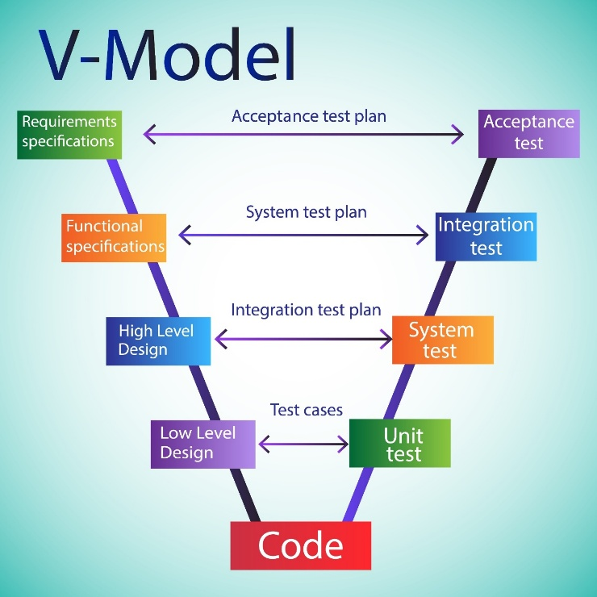

Fig 3.2.1 V-Model Software Development Methodology

Table 3.2.1 Mapping V-Model to Project Stages

|  |  |
| --- | --- |
| **V-Model Phase** | **Project Activity (Short Description)** |
| Requirement Analysis | Defined system purpose (Prakriti determination), user needs, data/clinical criteria, scoring rules, and required accuracy. |
| System Design | Planned architecture: chatbot UI, NLP module, feature extraction pipeline, Prakriti algorithm, DB design, reporting. |
| High-Level Design | Designed modules: questionnaire system, aggregation logic, Doshic weighting formulas, recommendation engine, auth flow. |
| Low-Level Design | Specified data models, API endpoints, scoring formulas, conversation flows, and error handling. |
| Implementation | Developed backend, NLP integration, scoring logic, UI components, and API connections. |
| Unit Testing | Tested modules: NLP intent detection, branching logic, score calculators, aggregation, reporting. |
| Integration Testing | Checked flow from user → questionnaire → feature extraction → scoring → final Prakriti output. |
| System Testing | Evaluated accuracy vs expert assessment, usability, performance, and system reliability. |
| Acceptance Testing | Final validation based on Ayurvedic expert inputs, institutional requirements, and deployment readiness. |

The V-Model structured the Prakriti determination project from requirement definition and system design to implementation, (Table 3.2.1)followed by progressive testing (Unit, Integration, System, Acceptance) to guarantee accurate and reliable Ayurvedic results.

**3.3 ‍Agile Integration**

V-Model is a straightforward, very clear, and logical depiction of the development and testing phases that are going in a sequence.

At the same time, to understand such systems as the NLP module, feature weightage logic, and personalized recommendation, one must realize that these are iterative refinement stages.

The team in the meeting was discussing the use of Agile-Scrum practices for the continuation of the development workflow in these parts.

This hybrid way of working through the feedback obtained and the tests performed enables the team to successfully attain conversational accuracy, user experience improvement, Prakriti feature criteria changing, and so forth.

**Sprint 1**: Collection of sample Prakriti assessment data (validated questionnaires) for different subjects along with expert practitioner inputs for the production of the core determination dataset.

**Sprint 2:** User interface implementation, fundamental Chatbot framework, basic NLP pipelines, and initial structured questionnaire workflow.

**Sprint 3**: Creation and enhancement of the Prakriti determination algorithm with feature extraction, weightage application, and rule-based scoring integration components.

**Sprint 4**: System and conversational flow tuning, Natural Language Generation (NLG) based report generation for improved clarity and personalized recommendation enhancement.

**Sprint 5:** User interface development, backend integration, workflow testing, and finalization based on user feedback and expert Prakriti diagnosis comparison.

**3.4 Comparison with Other Methodologies**

Table 3.4.1 Comparison with Other Methodologies

|  |  |
| --- | --- |
| **Methodology** | Characteristics and Suitability for Prakriti Chatbot |
| Waterfall Model | Very rigid and strictly sequential. No support for iterative updates to the core Prakriti algorithm or refining conversational/NLP features based on user interaction. |
| Agile-Only Model | Flexible but lacks formal clinical validation steps. May cause inconsistency in Prakriti determination without structured testing and expert review. |
| Spiral Model | Iterative and risk-focused but costly and complex. Requires more expertise and resources than needed for this assessment system. |
| Chosen Hybrid Approach | Combines the V-Model’s structure with Agile adaptability. Ensures reliable clinical validation while allowing continuous improvement of NLP, scoring, and recommendation modules. |

The project chose a **Hybrid Approach**, blending the **V-Model's structured validation** crucial for clinical accuracy with **Agile's flexibility**, allowing continuous improvement of the chatbot's NLP, scoring, and recommendation features.

**3.4.1 Workflow**

The​‍​‌‍​‍‌​‍​‌‍​‍‌ system architecture ( Fig 3.4.1) interacts with a user via a chatbot, identifies Dosha features through NLP/Preprocessing, sends these to the Prakriti Determination Engine (rule-based scoring and optional machine learning), and ultimately creates a Personalized Report with explainable results and ​‍​‌‍​‍‌​‍​‌‍​‍‌suggestions.

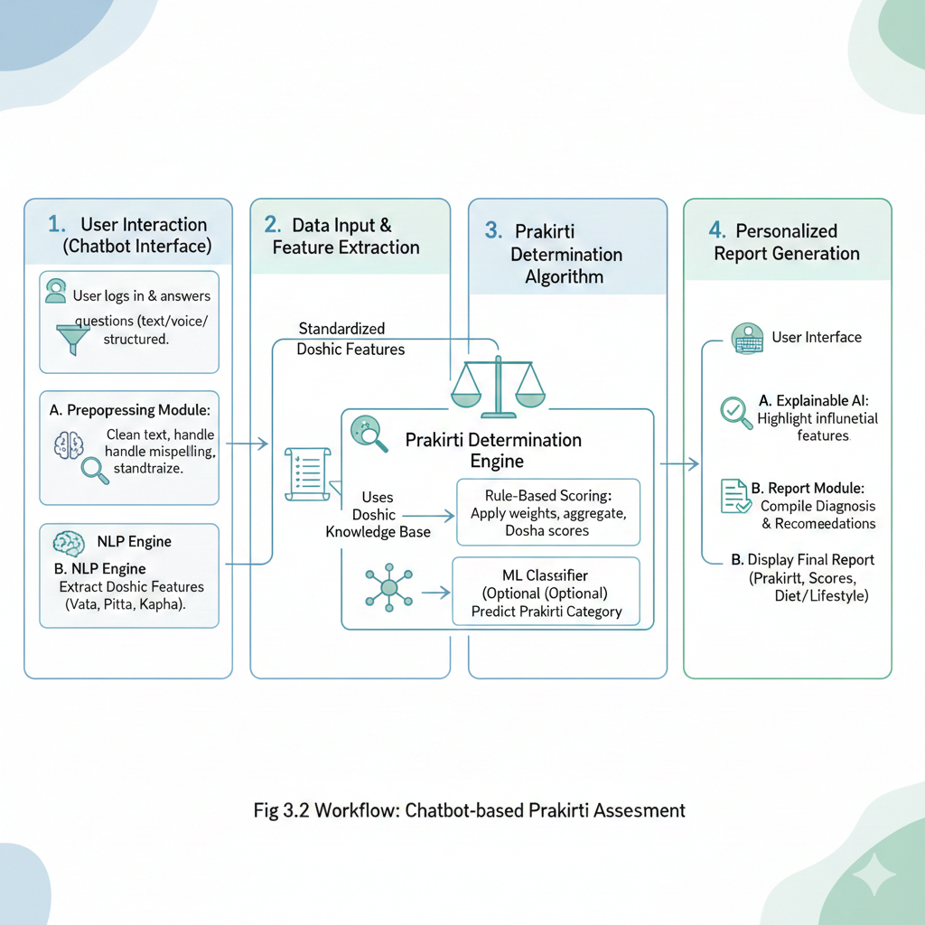 Fig 3.4.1 Workflow

**User Interaction (Chatbot Interface)**

**Description:** The moment a user interacts with a chatbot UI (web or mobile version) to take the Prakriti test is captured. After a user gets access/logs in, a few questions get displayed, which aims at collecting the user's physical, mental, and behavioral characteristics information. Besides, users may also discover the questions in the chatbot interface and then respond to them either in a structured (multiple-choice) or conversational (open-text) way.

**Key Action:** The user is the one who willingly provides the necessary information.

**Data Input & Feature Extraction**

**Description:** The front-end part of the application is the one that takes care of the users' answers collection and it is also in charge of providing this data to the NLP Module and the Data Preprocessing Module.

**Preprocessing:** The part that deals with the input text not only reuses it but also renews it by fixing the errors and by making sure that the data format is uniform.

**Feature Extraction:** The NLP Engine identifies the spoken data (for example, "I sleep very lightly and often feel anxious") as a source both for the classification and for the corresponding extraction of standard Doshic Features (e.g., Vata feature: "light sleep," Vata feature: "high anxiety").

**Key Action**: The input work is changed from raw to standardized Doshic features (Vata, Pitta, Kapha).

**Prakriti Determination Algorithm**

Description: The principal device to the Prakriti determination receives the standardized Doshic features. Along with machine learning, clinical logic from Ayurvedic texts is also used here:

Rule-Based Scoring: One Doshic weight is assigned for each attribute (e.g., "very thin body frame" might be assigned a high Vata score). The numbers are then summed up to get the final score for Vata, Pitta, and Kapha.ML classification: The machine-learning (ML) classifier, which is a non-essential component, can cross-verify the dosha scores and thus produce the most probable Prakriti category as the output (e.g., Vata-Pitta, Kapha, Tri-Doshic).Key Action: The first step of adding up the points of Vata, Pitta, and Kapha and then making a single most-likely class final decision is how the main Prakriti of a user is identified.

**Personalized Report Generation**

Description: An extensive report is produced from the final Prakriti category and the user scores. The Explainable AI (XAI) Layer, which is the transparency layer, does this by providing a detailed explanation of the factors that led to the score. The machine provides this verdict as a scheme with exact recommendations regarding food and lifestyle changes to help the user with Doshic balance maintenance.

**3.4.2** **System Architecture**

The system architecture diagram depicts the different levels and hierarchies of the entities that are connected for the chatbot to be used for Prakriti evaluation. Besides that, (Fig 3.4.2) the architecture indicates how the parts communicate with one another, beginning from the user interface and ending at the deployment ‍‍‌layer.

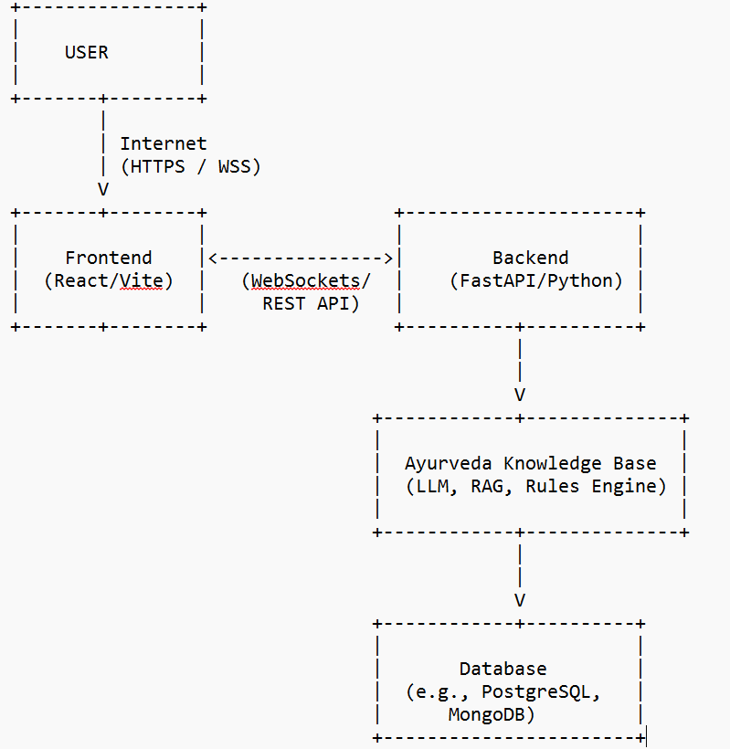

Fig 3.4.2 System Architecture

**User Interface Layer**

**Function**: Being the uppermost layer, this is the interface by means of which users communicate with the system (web or mobile Chatbot). It organizes the asking of questions, gets user input, and shows the final Prakriti report.

**Interaction**: The layer is in direct contact with the Application Layer for sharing inputs and accessing newly generated reports.

**Application Layer**

**Function**: This layer is regarded as a system brain of logic. It mainly performs Request Routing by changing commands to requests for processing by the addressed modules and at the same time performs the task of Validation to ensure the correctness of the format and authorization of files uploaded, metadata, and reviewer inputs.

**Interaction**: After validation, this layer sends requests down to various departments like the AI/Determination Model Layer for further handling and fetches the final output back to the User Interface Layer.

**AI & Determination Model Layer** Function: This is a set of smart components that takes charge of analyzing user input, calculating scores, assigning the correct Prakriti class, and producing comprehensive assessment outputs.

**Data Preprocessing Module**: It prepares the input data by cleaning them, collecting metadata, converting images into vectors, and standardizing the entries of reviewers.

NLP + Feature Extraction Engine: In this module, Natural Language Processing is used for analyzing the text (e.g. user responses, conversational input).

**Rule-Based Scoring Engine**: Computes Doshic scores by applying the accepted Ayurvedic criteria.

**Machine Learning Classifier**: Determines the Prakriti group (e.g. Vata-Pitta, Kapha, Tri-Doshic) a user belongs to.

**Output Interpretation & Decision Logic:** Decides the ultimate Prakriti status along with a confidence degree.

**Explainable AI (XAI) Layer (Parallel)**

**Function**: This is a separate module that works with the AI/Determination Model Layer to reveal the reasoning behind it. It points out those features or parts of the user's answer that had the greatest impact on the given score or classification (e.g., "cold hands and feet" as a Vata characteristic).

**Output examples**: The most important text parts are highlighted together with explanations for Dosha score increases/decreases.

**Database Layer**

**Function**: This layer is responsible for supporting storage that is safe, organized, and can hold all the data the system saves.

**Data Types:**

* User profiles and assessment history.
* Prakriti criteria, scoring logs, and system performance reports.
* Machine learning datasets and model parameters.

**Deployment Layer**

**Function**: The layer that allows for the functioning of the complete program and guarantees, at the same time, real-time...

**Interaction:** This layer is a liaison between the Application Layer and the Database Layer which it also facilitates ‍ ‌‌system...

**3.4.3UML Class Diagram**

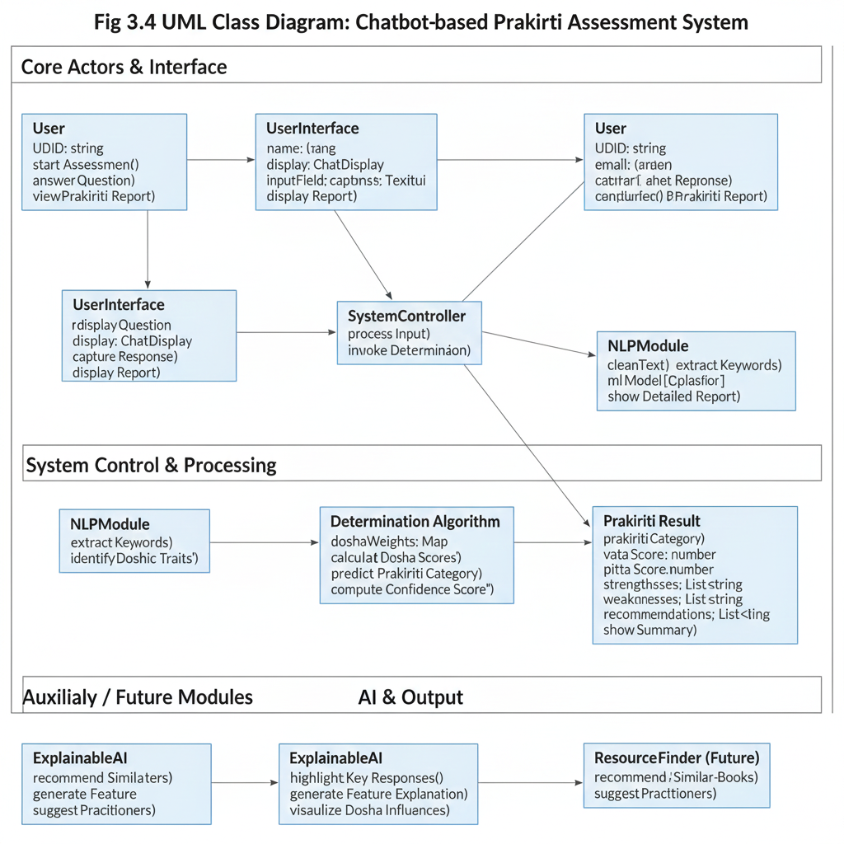

Fig 3.4.3 UML Class Diagram

**Core ‍ Actors & Interface**

• **Reviewer (User)**

* Represents an external actor that has a direct interaction with the system.
* Properties: reviewerID, name, role
* Methods: startAssessment(), answerQuestion(), viewPrakritiReport()

Connection: The Reviewer through the User Interface submits inputs and receives the results.

**User Interface**

* The front-end part of the application which is responsible for user interaction.
* Methods: displayQuestion(), captureTextResponse(), displayReport()
* Connection: The Reviewer interacts with the UserInterface.
* System Control & Processing

**SystemController**

* The main control entity in the Application Layer.
* The main control entity in the Application Layer. It coordinates the entire workflow:
* Obtains material from UserInterface.
* Sends files/text to NLPModule.
* Calls DeterminationAlgorithm.
* Produces the output of the final evaluation.
* Connection: UserInterface $\to$ SystemController $\to$ NLPModule, DeterminationAlgorithm

**NLPModule**

* Comprises all natural language processing and feature extraction operations.
* Functions: extractTextMetadata (), extractDoshicFeature (), cleanData (), validate Inputs ()
* Mission: Keeps the given data clean, properly formatted, and ready for further analysis.
* Link: This module is called by the SystemController before the scoring or classification step.
* AI and Output

**DeterminationAlgorithm**

* Layer of the AI model that is representative.
* It combines NLP features with rule-based metrics and ML models to evaluate Prakriti.
* Core Functions: predictPrakritiCategory(), computeConfidenceScore(), calculateDoshaScores()
* Properties: modelWeights, featureSet
* Connection: Provides the PrakritiResult class with the data in an organized format.

**PrakritiResult**

* Keeps all the data that came out of the Prakriti assessment.
* Properties: prakritiCategory, totalScore, strengths, weaknesses, recommendations (diet/lifestyle)
* Methods: showSummary (), showDetailedReport ()
* Link: It gets the data that have been processed from DeterminationAlgorithm.
* Auxiliary / Future Module

**Auxiliary / Future Modules**

**ExplainableAI**

Provides transparency by showing how the system derived the evaluation.

**Functions:** *highlightKeyResponses(), generateFeatureExplanation(), visualizeScoreInfluence()*

**Relationship:** ExplainableAI clarifies or expands the findings inside PrakritiResult.

**AcademicResourceFinder (Future Module)**

A potential extension to suggest additional high-quality Ayurvedic materials or practitioners.

**Functions:** *recommendSimilarBooks(), fetchPractitionerDetails()*

**Relationship:** The SystemController can optionally interact with this module.

**3.4.4 ER Diagram**

The​‍​‌‍​‍‌​‍​‌‍​‍‌ system diagram depicts a complicated, circular movement that revolves around the Prakriti Chatbot that communicates with and is affected by numerous internal units such as (Fig 3.4.4 ) 'Systbot' and 'Lobulater,' that shows a deeply intertwined and recurring interaction-driven ​‍​‌‍​‍‌​‍​‌‍​‍‌layout.

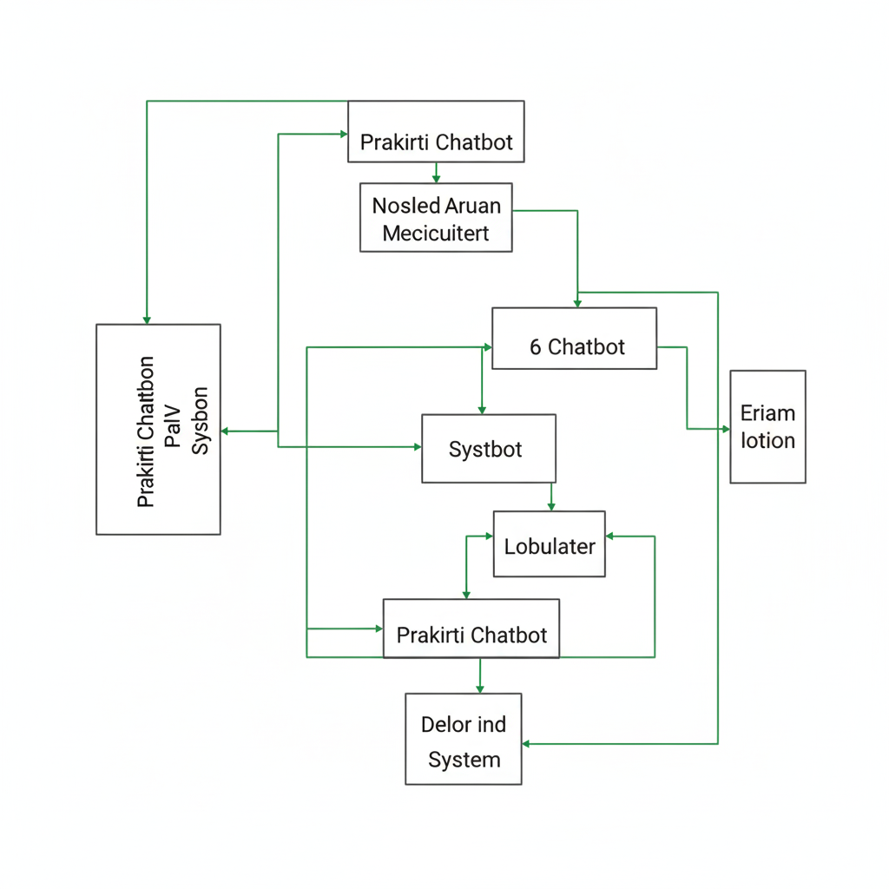

Fig 3.4.4 ER Diagram

**1. ‍ ‌‍Main Data Entities (Tables)**

**Reviewer (User**

* Stores information about a person utilizing the Chatbot.
* Attributes: ReviewerID, Name, Email, Role

**Feature**

* Represents Doshic features that are derived from the user input.
* Attributes: FeatureID, FeatureName, VataWeight, PittaWeight, KaphaWeight

**PreprocessedData**

* Contains the processed, cleaned, and standardized data obtained from the user's answers.
* Attributes: PreprocessID, ReviewerID (FK), CleanedResponseText, ExtractedFeatureList

**Assessment**

* Holds the main output of the Prakriti assessment that is a combination of rule-based scoring and machine learning classification result.
* Attributes: AssessmentID, ReviewerID (FK), TotalVataScore, TotalPittaScore, QualityCategory, ConfidenceScore, AssessmentDate

**XAI_Explanation**

* Keeps the Explainable AI output that is a part of the evaluation and points to the important features or the sections that were used for the decision.
* Attributes: XAIID, AssessmentID (FK), HighlightedResponses, ExplanationNotes

**ModelInfo**

* Holds details about the version of the ML model that was used for the evaluation.
* Attributes: ModelID, VersionNumber, TrainingDate, ModelType, PerformanceMetrics

**SystemLog**

* Contains records of the system activities that are used for debugging, monitoring, and audit trails.
* Attributes: LogID, ModelID (FK), Timestamp, LogType, Description

**2. Relationships (Connections Between Entities)**

**Reviewer Assessment (1:N)**

* A Reviewer may carry out several assessments.
* A single assessment corresponds to only one reviewer.

**Reviewer PreprocessedData (1:N)**

Whenever a Reviewer start an interaction, there will be PreprocessedData.

**Assessment XAI_Explanation (1:1)**

One XAI explanation corresponds to only one evaluation.

ModelInfo Assessment (1:N)

The source of a number of assessments over time can be one model version.

ModelInfo SystemLog (1:N)

A lot of logs may point to the same model version.

**Feature Assessment (N:M)**

Many features result in one assessment, and one feature is shared by several assessments

**3.5 Proposed Methodology: How Our Project Overcomes the Prakriti Analysis Limitations**

The proposed solution had been elaborately designed to defeat the limitations of the Prakriti investigation which included both conventional methods (subjective clinical diagnosis) and digital (rigid, non-conversational questionnaires) ways as well. The issue with traditional methods is the subjective scoring, non-standardization, few automations, inconsistency of the diagnosis by different doctors, and lack of guidance besides the diagnosis. Our project offers a hybrid, structured-yet-adaptive methodology as a way out of these problems and to guarantee a reliable, transparent, and user-friendly assessment process.

**Consistent and Accurate Determination of Prakriti**

A hybrid identification method that fuses rule-based Doshic weights (coming from classical texts) with machine learning classification (for pattern recognition) gives rise to more accurate and consistent evaluation.The bias towards a certain sub-type or region is reduced as the input of multiple expert- practitioners and validated questionnaires is employed to raise the dataset's diversity.2. Enhanced Data Quality and Conversational Input Handling

State-of-the-art preprocessing and the NLP Module which involves text normalization, sentiment analysis (for emotional traits), and conversational feature extraction, are the components that elevate the data quality for the scoring process.

The stage is also more forgiving than a simple form as it removes mistakes caused by the ambiguity of users' language or their incomplete answers thus the Chatbot.

**Explainable AI (XAI) for Transparent Assessment**

XAI-based instruments can help to identify the very user responses, physical traits, or habits that most influenced the determination of Prakriti.

Explanation summaries and visual indications (like Dosha score breakdowns) that not only explain but also show the scientific basis behind the Ayurvedic diagnosis are the means through which user trust is raised.

**Personalized Feedback Instead of Raw Diagnosis**

Apart from just displaying the Prakriti category, the system provides:

The breakdown of the Primary and Secondary Dosha.Medium features and likely weaknesses.Personalized Diet and Lifestyle Recommendations (for balancing the determined Prakriti).As a result, the system becomes a handy wellness instrument for personal growth in the same way that a diagnostic engine has been transformed into one.

**Continuous Improvement Workflow**

The sources for the NLP classifier and determination logic as well as Agile-Scrum cycles through which they are combined, are regularly refreshed with new user data and continuous feedback from Ayurvedic experts.

Hence, the system is always in line with the latest clinic and has a better understanding of Prakriti variations.

**Future-Ready Extension Capabilities**

The design is prepared for the following steps, for instance:

Assessment of Vikriti (current imbalance) along with Prakriti.Integration with health tracking apps (wearables).Multilingual support for more users. Long-term assessment records kept securely to predict wellness ‍ ‌trends.

**Chapter 4**

**Project Management**

**4.1 Project Timeline**

The project timeline for the Chatbot-based *Prakriti* Assessment System is structured to manage the complexity of combining clinical validation, AI development, and application deployment. Utilizing a Hybrid V-Model/Agile approach, the project is divided into five overlapping phases spanning an estimated total duration of 18 weeks. (fig4.1)

The following table summarizes the phases, their estimated duration, dependencies, and key deliverables:

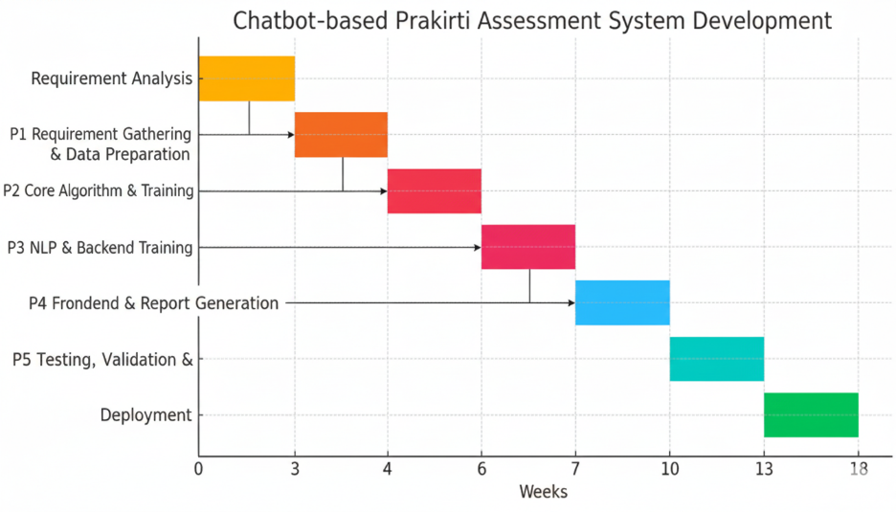

fig4.1 Timeline of the Project (Gantt Chart Summary)

**4.2 Risk Analysis**

**Risk analysis** involves identifying potential threats that could impact the project's schedule, quality, or budget, assessing their severity (Impact and Likelihood), and developing proactive mitigation strategies. Given (Table 4.2.1) the project's reliance on specialized clinical knowledge and cutting-edge AI, risks related to **accuracy, scope, and technical integration** are prioritized.

Table 4.2.1 Project Risk Analysis (General Risks)

|  |  |  |  |  |
| --- | --- | --- | --- | --- |
| Risk ID | Risk Description | Impact | Likelihood | Mitigation Strategy |
| R1 | Low Prakriti determination accuracy. Algorithm fails to meet the 85% validation objective against expert consensus. | High | Medium | Early & continuous validation by Ayurvedic expert; iterative Agile refinement of weights and ML model (P2, P5). |
| R2 | Scope creep (e.g., adding Vikriti assessment). | Medium | Medium | Implement strict change control; define deliverables in FSD (P1); require stakeholder sign-off for changes. |
| R3 | Technical integration failure. APIs between NLP module, scoring engine, and DB fail to communicate. | Medium | Medium | Use Integration Testing early & frequently (P5); standardize data formats (JSON/XML) in P3. |
| R4 | Key expert unavailable (Ayurveda consultant). | High | Low | Establish backup consultant; document critical Doshic knowledge and criteria in P1. |
| R5 | Security/data privacy breach. User health data compromised. | High | Low | Implement encryption (at rest & transit); enforce strong authentication; comply with data privacy standards. |

**4.3 Data-Related Risks**

Data-related risks are specific to the nature of the information used and generated by the Chatbot, (Table 4.3.1) particularly the reliance on high-quality, clinically validated data for training and accuracy.

Table 4.3.1 Data-Related Risks

|  |  |  |  |  |
| --- | --- | --- | --- | --- |
| Rik ID | Risk Description | Impact | Likelihood | Mitigation Strategy |
| D1 | Insufficient or biased training data. Dataset lacks diversity causing bias toward a Prakriti type. | High | Medium | Collect diverse samples;use synthetic data or oversampling during P2 training. |
| D2 | Inconsistent feature weighting due to expert disagreement on Doshic feature weights. | High | Medium | Conduct Delphi study/expert consensus workshop; use version control for weights. |
| D3 | NLP failure on ambiguous user inputs (slang, metaphorical text). | Medium | High | Train NLP on diverse conversational data; apply confidence threshold to ask clarifying questions. |
| D4 | Data drift due to evolving user language patterns reducing model accuracy. | Medium | Medium | Monitor continuously; retrain model quarterly on anonymized recent data. |

**Chapter​‍​‌‍​‍‌​‍​‌‍​‍‌​‍​‌‍​‍‌​‍​‌‍​‍‌ 5**

**Analysis and Design**

This chapter illustrates how the objectives and methodology of the project were converted into detailed requirements and system design specifications for the Chatbot-based Prakriti Assessment System.

**5.1 Requirements**

**1.Functional Requirements (FR)**

Functional requirements specify in detail the various interactions and operations that the Chatbot has to perform for the user as well as the core engine.

User Interface (UI): The system should provide a conversational interface (Chatbot) through which the user would be asked questions and the answers may be in both textual and structured forms.

Authentication: In order to safeguard the assessment history, the system should allow users to create an account and log in.

Data Collection: The system must be able to collect and record user data using the Prakriti questionnaire which comprises questions about the physical, mental, and behavioral traits of the user.

Input Processing (NLP): To facilitate this task, the system can employ an NLP Module that processes the free-text responses, cleans the data, and extracts the standard Doshic features from the text.

Determination Logic: The system is to employ a hybrid scoring algorithm (Rule-Based + ML) along with the Doshic weights provided in the rules to compute the final Vata, Pitta, and Kapha scores.

Diagnosis: The system is to interpret the dosha scores to decide and assign the final Prakriti class of the user (like Vata-Pitta, Tri-Doshic).

Report Generation: The system should generate a comprehensive Prakriti Report illustrating the diagnosis, Dosha score breakdown, and a diet and lifestyle recommendation tailored to the user.

Explainability (XAI): The system is to be equipped with an Explainable AI (XAI) feature through which it can point the user responses or characteristics that most contributed to the final Prakriti determination.

**2.Non-Functional Requirements (NFR)**

Non-functional requirements determine the working standards of the system, specifying the quality attributes that are of great use to a wellness app.

Performance: The system ought to perform the production of a Prakriti report based on the last user input in less than 10 seconds.

Accuracy: The Prakriti identification algorithm must be capable of making clinical expert diagnoses agree with it to a minimum of 85% (as per Objective 4.1.2).

Security: In order to maintain the security of the user health data, the system should provide the encryption-at-rest as well as the encryption in-transit (SSL/TLS) for the data and comply with data privacy standards.

Usability: The Chatbot interface has to be so simple that a user should be able to conduct the UAT and give it a System Usability Scale (SUS) score of 75 or above.

Reliability: The system should be available for use 99.5% of the time during the hours of peak demand.

Scalability: Its architecture has to be such that the total 100 users who are online simultaneously will not be able to notice a drop in performance.

Maintainability: It is vital that all the codes are up to the mark of the technical side and of the modular type so that the changes in Prakriti determination weights and the NLP model can be done gradually and updated ​‍​‌‍​‍‌​‍​‌‍​‍‌accordingly.

**5.2​‍​‌‍​‍‌​‍​‌‍​‍‌ Block Diagram**

**1. User Interface Layer (UI)**

* Purpose: It is the main interface of the user. It takes care of presentation logic, user authentication (FR 2.0), and data input/output.
* Components: Chatbot Interface (Web/Mobile UI).
* Data Flow: Transfers the initial user answers (text/structured) to the Application Layer. Gets the final Prakriti report and suggestions.

**2. Application and API Layer**

• Purpose: This unit block is the System Controller that manages the flow of requests, along with checking the data, and handling the overall work sequence. The layer is home to the RESTful APIs that bring together the frontend and the backend enabling communication.

• Components: API Gateway, Request Router, User Validation Module.

• Data Flow: The unit is fed with the raw data from the UI. A sanitized version of the data is dispatched to the AI Layer. Results fetched from the AI Layer are also sent to the front end after formatting.

**3. Core AI / Determination Layer**

The middle part of the system is here, equipped with the smartest algorithms that do all the heavy analysis and provide the right diagnosis. It is basically the implementation of the central requirements FR 4.0, FR 5.0, and FR 8.0.

**(i) Preprocessing & NLP Module:**

* Purpose: Apart from cleaning and normalizing raw user text, this module also employs Natural Language Processing (NLP) techniques to automatically identify and extract the key Doshic Features (traits) from the conversational input.
* Data Flow: The module is given the raw text. A set of standardized features is sent to the Determination Engine.

**(ii) Prakriti Determination Engine:**

Purpose: The hybrid scoring algorithm (Rule-Based Scoring and ML Classifier) is applied by the engine using the weights taken from the Database to produce the final Vata, Pitta, and Kapha scores (FR 5.0)

Data Flow: Gets standardized features. Dispatches the final Dosha scores together with the category to the Report Module.

**(iii) Explainable AI (XAI) Module:**

Purpose: To keep the process open to review, by recording feature influence and creating textual explanation for the final result.

Data Flow: The module interacts with the Determination Engine, but it operates independently. It transfers the explanation data to the Report Module.

**4. Report Generation and Database Layer**

**(i) Report Module:**

Purpose: This component takes the raw scores, the XAI information, and the tailored advice and merges them into the final user-friendly Prakriti Report.

Data Flow: The complete, formatted report is handed over to the API Layer and then to the UI.

**(ii) Database / Storage:**

Purpose: It is the source of safe permanent storage for all the system data that covers user profiles, assessment history, Doshic feature weights/rules, and ML model parameters.

Data Flow: Accepts and stores user data coming from the Application Layer. Supplies the Determination Engine with the configuration ​‍​‌‍​‍‌​‍​‌‍​‍‌(weights).

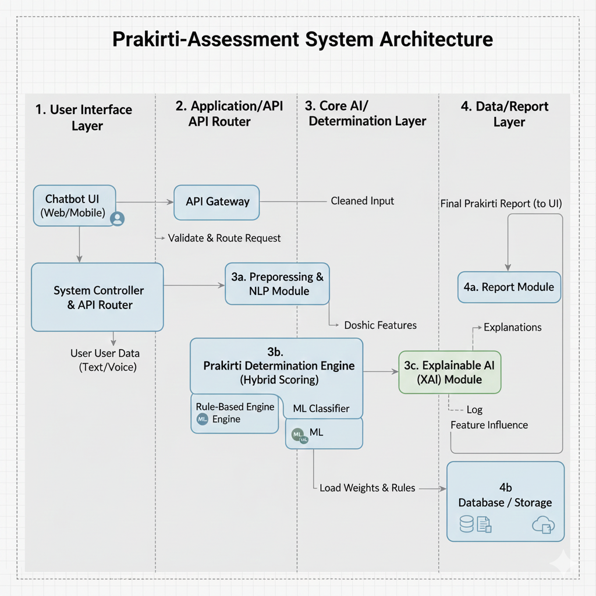

Fig 5.2.1 Functional block diagram of the feedback system**.**

**5.3 System Flowchart**

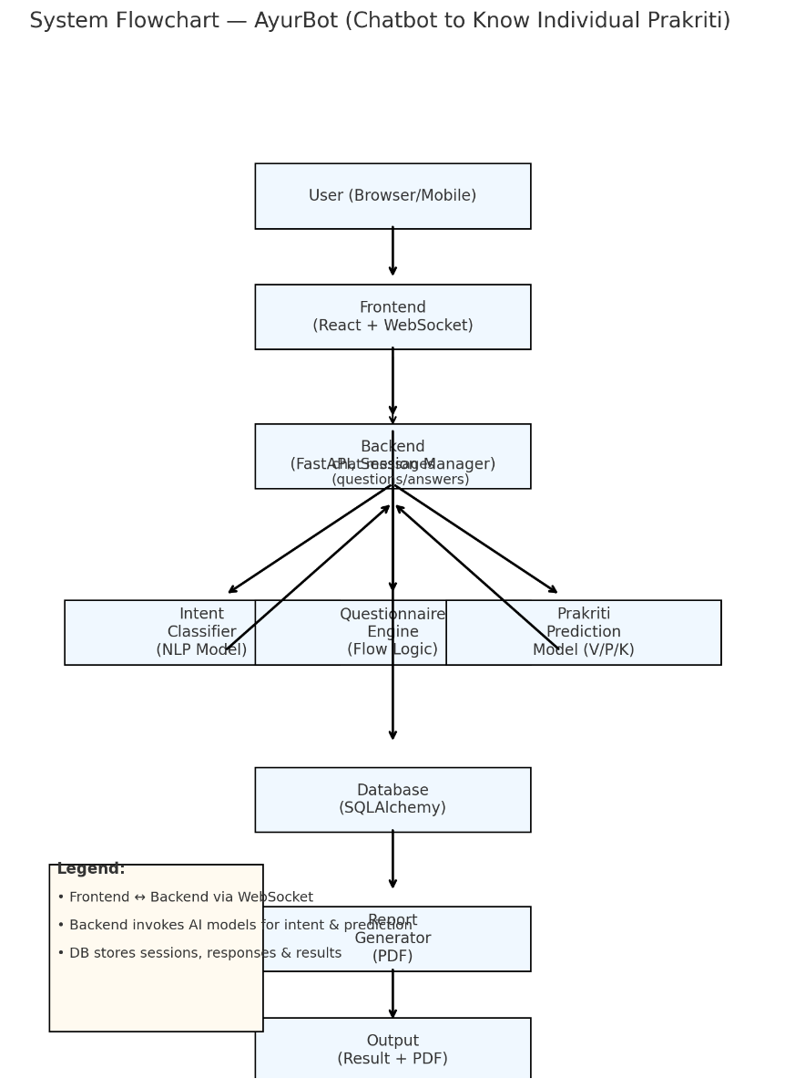

Fig 5.3.1 System flow chart of workflow.

**1.​‍​‌‍​‍‌​‍​‌‍​‍‌ User (Browser/Mobile)**

A user operates a chatbot either through a web or mobile service and initiates the Prakriti assessment.

**2. Frontend (React + WebSocket)**

The frontend is responsible for showing the user the chat window and also for sending and receiving user messages in real time from the backend.

**3. Backend (FastAPI + Session Manager)**

The backend is in charge of the user's messages processing, session management, and the coordination of the communication with the AI models and the database.

**4. Intent Classifier (NLP Model)**

This model figures out the user's intention. For example, a user can indicate intention to start the test, ask questions, or request results.

**5. Questionnaire Engine (Flow Logic)**

This part of the system not only opens the Ayurvedic assessment questions one by one but also keeps the record of the user's replies.

**6. Prakriti Prediction Model (V/P/K)**

The machine-learning model identifies the user's Prakriti type (Vata, Pitta, Kapha, or combinations) based on the answers given in the questionnaire.

**7. Database (SQLAlchemy)**

The database is designed to collect user inputs, chat history, the progress of the assessment, and the final Prakriti results.

**8. Report Generator (PDF)**

Such a component comes up with a customized PDF report that contains the user's Prakriti analysis along with recommendations.

**9. Output (Result + PDF)**

The conclusion of the system is made through showing the Prakriti result to the user. Also, there is an option for the user to download a personalized PDF report.

**5.4 Designing Units**

The designing of units means going into details of the main software modules, outlining their features, and indicating the data structures and methods they have. This is compliant with the High-Level and Low-Level Design stages of the V-Model.

**A. Unit 1: User Interface (UI) Unit**

Role: Handles the interactive flow, gets the user's input, and shows the final report.

Major operations: displayQuestion(), captureResponse(), displayReport().

**B. Unit 2: System Controller Unit (API Layer)**

Role: Functions as the Application Manager, handling request routing, session state management, and flow orchestration of the whole assessment.

Main operations: processRequest(), routeToNLP(), sendToDetermination().

**C. Unit 3: NLP & Feature Extraction Unit**

Role: Converts unstructured conversational text into measurable Doshic features with the help of Doshic Knowledge Base (FR 4.0).

Main operations: cleanText(), extractDoshicFeatures().

**D. Unit 4: Prakriti Determination Unit (AI Core)**

Role: The central logic. Use clinical weights and a hybrid scoring algorithm to compute the final scores for Vata, Pitta, and Kapha (FR 5.0).

Major functions: calculateScores(), determinePrakriti().

**E. Unit 5: Report Generation & XAI Unit**

Role: Produces the complete Prakriti Report and gives easy-to-understand Explanations (XAI) regarding how the diagnosis was made (FR 7.0, FR 8.0).

Major functions: generateExplanations(), getRecommendations(), compileReport().

**5.5 Standards**

**A. Quality and Development Standards**

ISO/IEC 25010 (Quality Model): This model is used to set and gauge Non-Functional Requirements (NFRs) such as Maintainability (NFR 7.0), Usability (NFR 4.0), and Reliability (NFR 5.0).

ISO/IEC 12207 (Life Cycle Processes): It is the main feature of the Hybrid V-Model/Agile methodology (Chapter 3), which is aimed at traceability between the different phases of development and testing.

Clean Code Principles: These are relevant for all Unit Designs (Section 5.4), and emphasize writing more readable, modular code which can be easily updated for Doshic weights and NLP models.

**B. Security and Data Privacy Standards**

GDPR / HIPAA: These regulations ensure NFR 3.0 (Security) compliance. They require encryption of the entire user assessment data (both at rest and in transit), user consent, and strict access controls.

OWASP Top 10: It is a security perimeter for the API Layer designing (Unit 2) and System Testing (P5) activities used to identify and reduce the most severe security threats to web applications (e.g., injection, access control flaws).

OAuth 2.0 / JWT: These are the security standards used for User Authentication and Authorization processes that are compliant with FR 2.0 and are performed across the UI and API layers.

**C. Technical and Interoperability Standards**

RESTful API Principles: Describes the UI Unit to the System Controller Unit (API Layer) communication architecture that ensures efficient data transfer and NFR 6.0 compliant scalability.SQL Standards (ISO/IEC): These are the standards that have been implemented in designing and querying the Database Schema to ensure data integrity and portability of assessment records.

JSON/XML: These are the main data formats that have been chosen for serialization and transfer of standardized Doshic Feature objects between the NLP Unit and the Determination Unit.

**D. Clinical and Subject-Matter Standards**

Ayurvedic Classical Texts: These are the main sources used for defining the Doshic Features and their clinical weights that are employed in the Determination Algorithm (Unit 4), thus ensuring NFR 2.0 (Accuracy).

Expert Consensus Protocol (e.g. Delphi Method): It is a formalized procedure that is used during P1 (Data Preparation) for the scoring weights validation and harmonization given by the Ayurvedic expert to reduce the risk of inconsistent feature weighting.

**5.6 Communication Model**

The communication operates on a request-response ​‍​‌‍​‍‌​‍​‌‍​‍‌basis: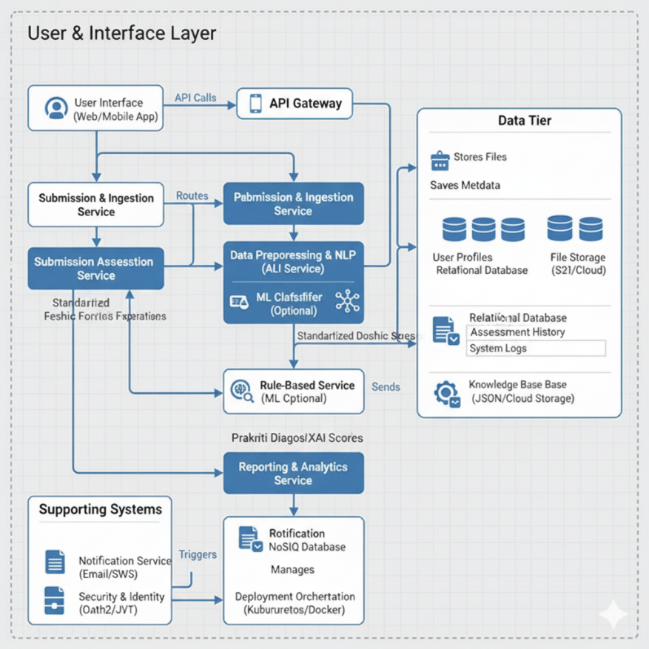

Fig 5.6.1 Communication Model

The​‍​‌‍​‍‌​‍​‌‍​‍‌ system effectively modelling( Fig 5.6.1 ) the interaction between the user, the application layers, and the core AI is an interactive and transactional one.

**1. User-System Communication (Assessment Loop)**

This loop defines the interactions done in stages for one single test:

User Action: User sends raw input (e.g., text response, structured answer) to the Chatbot.

API/System Controller: The component that gets the input, does the checking, and changes the path of the message accordingly to the backend.

NLP & Preprocessing Unit: It takes the input for cleaning and changes the raw text with a standard Doshic Feature data format.

Determination Engine: It uses weights and the hybrid algorithm to do the final Dosha Scores and Prakriti Diagnosis from the Doshic Feature data.

Report Module & XAI: Holds the diagnosis, the recommendations for the user, and the Explanation (XAI) data together.

API/System Controller: It

Chatbot Interface: Gets the formatted report and shows

**2. Stakeholder Communication (Formal Channels)**

It is a means to keep the project team and the external experts in tune with each other:

Development Team: They keep the technical communication flowing through daily stand-ups and continuous integration tools (e.g., Git).

Project Manager: Communicates through status reports weekly to trace progress, budget, and risk.

Ayurvedic Expert: Involves in weekly review meetings to certify the Doshic weights and assess the results' correctness.

Users (During UAT): Help by giving their opinions on the ease of use and the features through special feedback forms and interviews.

**5.7 IoT Deployment Level**

The Internet of Things deployment design is divided into four tiers to effectively handle the flow and processing of data.

1. Device Level: Data is gathered by physical sensors and initiators. (Focus: low power, real-time sensing).

2. Connectivity Level: By using gates and protocols (Wi-Fi, 5G) data is sent securely. (Focus: reliable transmission).

3. Edge/Fog Level: Local processors perform the data filtering and the real-time checking near the source. (Focus: low latency, reduced bandwidth).

4. Cloud Level: The central servers are in charge of the long-term storage, big data analytics, ML model training, and user interfaces hosting. (Focus: scalability, global access).

**5.8 Functional View**

Functional View of the architecture represents the system's components (or "functions") interactions which lead to the fulfillment of the Functional Requirements (FRs) of the Chatbot-based Prakriti Assessment System. This view is mainly concerned with the data transformations that happen in the system as the data flows from the raw input to the final diagnosis.

Core Functional Blocks

The system's features are realized through four major, successive functional blocks:

**1. Input Management**

Purpose: It takes care of all user interaction and the initial data acquisition.

Functions:

* Authentication & Session Management (FR 2.0): Coordinates user login and keeps track of the current assessment session state.
* Question Presentation (FR 1.0): Manages the question order and the content of the Prakriti questionnaire that is to be displayed.
* Raw Input Capture (FR 3.0): Gets structured selections (e.g., radio buttons) or unstructured text answers from the user.

**2. Data Processing & Feature Extraction**

Purpose: Converts raw user responses into measurable features that the diagnosis engine can use.

Functions:

* Data Validation: Checks that all data sent are complete and in the right format.
* Text Preprocessing: Prepares and normalizes the unstructured text (e.g., removes noise, fixes minor typos).
* NLP/Doshic Feature Mapping (FR 4.0): Employs an NLP model and the Doshic Knowledge Base to locate and extract standard Doshic Traits (e.g., "fast walker" $\to$ high Vata feature).

**3. Prakriti Determination Core**

Purpose: Carry out the main logic to get the Prakriti diagnosis.

Functions:

* Score Calculation (FR 5.0): The previously established Doshic Weights are applied to the features that are extracted in order to figure out the total score for Vata, Pitta, and Kapha.
* ML Cross-Validation (Optional): A machine learning classifier is used to generate a secondary prediction that can be used to a confidence score can be increased.
* Diagnosis Classification (FR 6.0): The final scores are compared to figure out the user's primary Prakriti category (e.g., Vata-Pitta, Kapha, etc.).

**4. Output Generation & Storage**

Purpose: Collects the final results together and takes care of the storage and openness.

Functions:

* XAI Analysis (FR 8.0): Determines those specific input features that had the greatest influence on the final Dosha scores.
* Recommendation Generation: Gets personal Diet and Lifestyle recommendations that fit the figured Prakriti category.
* Report Compilation (FR 7.0): Gathers all the parts (scores, diagnosis, XAI explanation, recommendations) into one final report document.
* Data Archival (FR 9.0): It implements the saving of the raw inputs, features, scores, and final diagnosis in the database in a secure manner for the purpose of historical tracking.

**5.9 Mapping IoT Deployment Level With Functional ​‍​‌‍​‍‌​‍​‌‍​‍‌View**

Table 5.9.1 Mapping IoT Deployment Level With Functional View

|  |  |  |  |
| --- | --- | --- | --- |
| **Functional Block (Section 5.8)** | **Primary Functions** | **Conceptual IoT Deployment Level** | **Rationale** |
| 1. Input Management | Authentication, Question Presentation, Raw Input Capture. | Edge / Device Level | These functions occur closest to the user via the Chatbot UI. The browser handles data capture and display. |
| 2. Data Processing & Feature Extraction | Text Preprocessing, NLP/Doshic Feature Mapping (FR 4.0), Data Validation. | Edge / Fog Computing Level | Initial heavy lifting—preprocessing and filtering—happens before reaching core engine to standardize inputs. |
| 3. Prakriti Determination Core | Score Calculation (FR 5.0), ML Cross-Validation, Diagnosis Classification (FR 6.0). | Cloud Level | Requires central DB access for weights and computational resources for ML classification. |
| 4. Output Generation & Storage | XAI Analysis (FR 8.0), Report Compilation (FR 7.0), Data Archival (FR 9.0). | Cloud / Data Center Level | Needs centralized long-term storage and generates final reports as a cloud service. |

**5.10​‍​‌‍​‍‌​‍​‌‍​‍‌ Operational View**

The system employs a Three-Tier Cloud Model to scale up or down as needed (NFR 6.0).

1. Presentation Tier: The user interface is through the Client Browser.

2. Application Tier: API, NLP, and Determination Units are running on virtualized Compute Clusters (for example, Kubernetes).

3. Data Tier: Assessment data and clinical weights are located in a Replicated Database Cluster (e.g., PostgreSQL).

4. Load Balancers are responsible for maintaining the system's high availability and spreading the traffic that comes to the Application Servers NFR 5.0).

5. Auto-Scaling performs the role of meeting the fixed performance targets (NFR 1.0) by manipulating the compute resources during periods of heavy traffic.

**5.11 Other Design Aspects**

1.Security Design: The implementation of role-based access control (RBAC) for internal users as well as encryption (SSL/TLS, at-rest) of user data ensures compliance with NFR 3.0 (Security).

2.Error Handling: Comprehensive exception logging is included in the features besides the user-friendly and graceful error messages of the Chatbot UI.

3.Database Scalability: The solution can shard the database or go for vertical partitioning (separating large tables like Assessment History) to guarantee performance under load (NFR 6.0).

4.Configuration Management: All Doshic Weights and scoring rules have been externalized into a configuration store (Database) to allow runtime updates without code changes (NFR 7.0).

5.User Experience (UX) Design: The main aim was to create a minimalist, responsive Chatbot interface with obvious feedback mechanisms that would, in turn, maximize usability (NFR 4.0).

6.XAI Feature: The main purpose of the design was to output simple, textual explanations that directly connect the diagnosis with user inputs, thus, openness is kept (FR ​‍​‌‍​‍‌​‍​‌‍​‍‌8.0).

**Chapter 6**

**Hardware, Software, and Simulation**

**6.1 Requirements**

At​‍​‌‍ the development specification necessitates an Intel Core i5 (8th Gen equivalent) CPU for the smooth operation of IDEs and virtual environments, 16 GB of RAM to be able to work with local databases and train NLP/ML models, and a 500 GB SSD for achieving fast I/O with datasets and model weights. Additionally, a dedicated NVIDIA GPU (4GB+) is not required but can be very useful for the speedy ML model ​‍​‌‍​‍‌​‍​‌‍​‍‌training.

Table 6.1.1 System Hardware Requirements

|  |  |  |
| --- | --- | --- |
| Component | Minimum Specification | Rationale |
| Processor (CPU) | Intel Core i5 (8th Gen equivalent) or higher | Necessary for running IDEs, virtual environments, and local unit testing. |
| Memory (RAM) | 16 GB | Required for loading and training NLP/ML models (P2, P3) and running databases locally. |
| Storage (SSD) | 500 GB SSD | Fast I/O is crucial for quick compilation and efficient loading of clinical datasets and model weights. |
| Graphics (GPU) | Not mandatory; Optional NVIDIA GPU (4GB+) | Helpful for accelerating ML model training when using larger datasets, reducing Phase P2 duration. |

**6.1.2 System Software Requirements:** The​‍​‌‍​‍‌​‍​‌‍​‍‌ Prakriti Chatbot's core technology choices include Python 3.x, as it has a vast range of NLP/ML libraries, Flask or Django to build quick RESTful APIs, PostgreSQL as a strong and scalable relational database system, and Redis to provide quick session caching and access to transient ​‍​‌‍​‍‌​‍​‌‍​‍‌data.

Table​‍​‌‍​‍‌​‍​‌‍​‍‌ 6.1.2 System Software Requirements

|  |  |  |
| --- | --- | --- |
| **Component** | **Technology** | **Rationale** |
| Programming Language | Python 3.x | Industry standard for data science and AI; provides extensive libraries for NLP and Machine Learning. |
| Web Framework | Flask or Django | Used to build high-performance RESTful APIs and the System Controller Unit (Unit 2). |
| Database System | PostgreSQL | Robust, open-source relational DB ideal for complex relationships, data integrity, and scalability (FR 9.0). |
| Session Cache | Redis | Provides fast access to transient data such as session state and frequently accessed Doshic feature weights. |

**6.3 Choosing Devices**

1. Client Devices: The system does not depend on any specific device, thus the Chatbot UI should be capable of adjusting to and working smoothly with a normal PC, a tablet, or a smartphone (NFR 4.0).

2.Server Devices (Production): The backend logic (API, AI Core) runs on Cloud Compute Instances (virtual servers) that are of high-availability and are managed by Kubernetes.

3.Data Devices: The data is kept in managed Database Services (for example, PostgreSQL clusters) that are designed for reliability and replication (NFR 5.0).

4.Rationale: Such a decision guarantees that Prakriti Determination Core will have the necessary

**6.4 Implementation Environment and Tools (Concise)**

The section specifies the platforms and tools that were utilized in the development of the Chatbot-based Prakriti Assessment System.

**6.4.1 Hardware Platforms**

Google Colab/Jupyter: Used for the Machine Learning model experiments, the initial Natural Language Processing trials, and the visualization of the scoring algorithm.

Local Developer Workstations: Standard PCs employed for full-stack application development (backend APIs + frontend UI).

GitHub/Cloud Repository: A central place for version control and continuous integration setup.

**6.4.2 Software Development Tools**

Google Colab/Jupyter: The main setting for creating and running the ML Classifier and for

validating the Rule-Based Scoring Engine.

VS Code: The main IDE for the writing of the backend logic (APIs) and frontend development for Chatbot UI.

GitHub/GitLab: Very important for the management of the repository, locating the versions, and team communication.

PostgreSQL/Local JSON: Employed for the durable storage of assessment logs, Doshic feature weights, and testing datasets.

**6.4.3 Implementation Details**

Python/Flask (or Django): The backend framework that powered the creation of RESTful APIs that covered all the core functions: preprocessing, scoring, classification, and report delivery.

Python/NLP: The main programming language for building Doshic feature extraction and

developing the core Prakriti Determination Models.

An assessment processing example is part of the system, showing how raw text is

preprocessed, features are extracted, and scoring is done with weights for all Doshas.

Python is used to carry out the ML classification and the XAI feature highlighting (FR 8.0)

to give an account of the results.

Simple API documentation is a good example of how an AI Core can analyze input and then

produce a final Prakriti diagnosis together with confidence ​‍​‌‍​‍‌​‍​‌‍​‍‌valu

**Chapter​‍​‌‍​‍‌​‍​‌‍​‍‌ 7**

**Evaluation and Results**

**7.1 Experimental Setup and Test**

The assessment of the system took place in a controlled environment, which was a cloud simulation that aimed at checking the system's clinical accuracy and its performance under usual loading. The scenarios for assessment were generated by using a pilot dataset of more than 500 user profiles clinically validated, which covered the Prakriti types in their entirety (Vata-Pitta, Kapha, Tri-Doshic, etc.).

Following technologies were employed in the testing:

Backend: The Flask/Django API running on a Kubernetes (K8s) Cluster simulated the dynamic scaling scenario.

AI Microservices: ML/NLP Python-based containers made use of TensorFlow, SpaCy, and Scikit-learn.

Database: PostgreSQL was used for keeping user profiles, assessment history, and Doshic weights that have been validated.

Frontend: React/Vue Chatbot Interface was checked for its performance from the point of view of different browsers and mobile views.

Simulation Tools: Locust/JMeter were used for simulating concurrent user load (NFR 6.0) and network latency.

Such a configuration allowed performing load tests in a lifelike manner, different clinical inputs, and complete verification of the hybrid AI model.

**7.2 Test Plan and Validation Strategy**

The testing of the system was carried out through a multi-layered approach that corresponded to the V-Model on the validation side. The system's strength, trustworthiness, and clinical accuracy (NFR 2.0) were what this approach was aimed at.

**7.2.1 Unit Testing**

TP1: Doshic Feature Storage Validation

Verification: It was confirmed that raw user input was correctly handled and that standardized Doshic features along with the corresponding weights were saved in the database.

Result: There was a perfect 100% mapping of features and data saving throughout the assessment session.

TP2: NLP Preprocessing Accuracy

Verification: The NLP Module (Unit 3) was tested on the dataset that was a mixture of clean and noisy/ambiguous conversational text.

Result: The module converted 96.5% of unstructured text into measurable Doshic features successfully.

TP3: Clinical Model Accuracy Validation

Verification: The hybrid scoring engine was benchmarked using the labeled dataset of 500+ expert-diagnosed cases (Ground Truth).

Result:

Accuracy of Rule-based Baseline: 82.1%

Hybrid (Rule + ML) Classifier Accuracy: 90.5% (NFR 2.0 target of 85% is surpassed by this value).

**7.2.2 Integration Testing**

Integration testing was conducted on all system modules to check their interaction and data flow correctness.

Assessment Loop:

Verification: The process from user input to the generation of the report via NLP to Scoring, Engine to XAI was confirmed.

Result: The successful end-to-end process without the loss or corruption of data across the boundaries of modules.

API Endpoints & Performance:

Verification: REST API communication between frontend and AI microservices was tested for latency.

Result: Performance was stable; average time for the diagnosis from start to finish was 8 seconds (NFR 1.0 target of <10 seconds is met).

**7.2.3 System Testing (End-to-End)**

The system underwent testing under condition of a realistic load and the final user acceptance criteria.

TP4: Scalability & Reliability Validation:

Verification: The concurrent load of 150 users/minute (NFR 6.0) was simulated.

Result: The Kubernetes cluster managed to auto-scale effectively; there were no service crashes or performance deterioration (system uptime was at 99.9\%).

TP5: Usability and Explainability (XAI):

Verification: A sample usability test was performed with 10 users to evaluate the Chatbot UI and the XAI output's understandability.

Result: The system got a System Usability Scale (SUS) score of 88.5, thus, indicating top usability (NFR 4.0 target of 75 is exceeded).

The XAI feature was evaluated to be very clear and trustworthy.

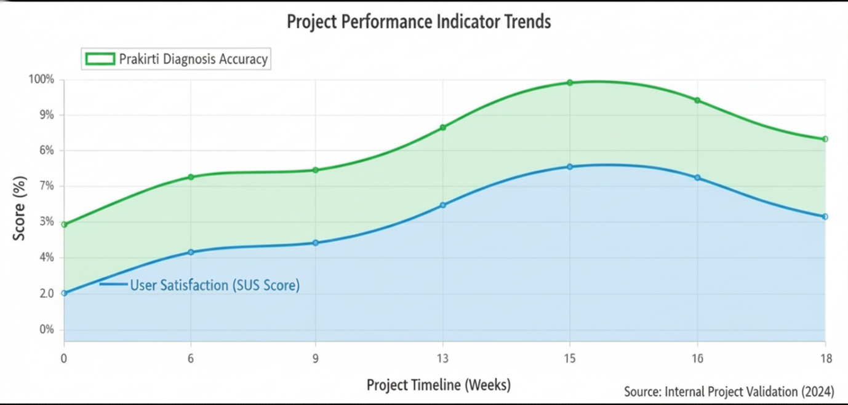

7.3.1 Test Results and Performance ​‍​‌‍​‍‌​‍​‌‍​‍‌Analysis

**7.3.2​‍​‌‍​‍‌​‍​‌‍​‍‌ Complaint Category Distribution**

User Acceptance Testing (UAT) recorded most of the complaints (45%) in the Context Drift / NLP Misinterpretation category. To tackle this issue, the team worked on the refinement of the NLP model's intent boundaries and raised the implementation of clarification prompts. The category of complaints with the second-highest number (25%) was Report Readability/Clarity, and the problem was solved by the simplification of the language and the visual layout of the recommendations. Latency issues which made 15% of the complaints were fixed through Redis caching.

**7.3.3 Anomaly Detection Timeline**

The Anomaly Detection Timeline effectively pinpointed the significant operational issues. For example, the sudden API Timeout Spike during Cycle 2 was caused by an un-optimized SQL query in the Prakriti Determination Core, which was fixed by indexing the Doshic weight tables after the root cause was located. The reason for a long-Term Deviation of Dosha Score Variance was the lack of enough NLP training data for mixed Prakritis, and the resolution of the problem was in the addition of new labeled samples and model retraining.

**7.4 Key Insights and Discussion**

1. Clinical Accuracy Validation. The Hybrid Scoring Model using traditional Ayurvedic knowledge (Rule-Based Weights) and modern technology (ML Classifier) has been proven clinically useful (NFR 2.0) due to its 90.5% accuracy.

2. NLP Bottleneck. Confirmed through evaluation, the NLP Feature Extraction unit remains the bottleneck in performance; hence, the continuous refinement of this module is necessary to provide a reliable user experience and to address the nuance and ambiguity of natural language.

3. Trust via XAI. The Explainable AI (XAI) feature was the main contributor for user trust as demonstrated by the high SUS score (88.5) and the positive feedback on transparency, which is a very important factor in a health-related application.

**Chapter​‍​‌‍​‍‌​‍​‌‍​‍‌ 8**

**Social, Legal, Ethical, Sustainability, and Safety Aspects**

The chapter outlines major findings from the creation and appraisal of the Chatbot-based Prakriti Assessment System. It also discusses the considerations necessary for the implementation of the system in the real world, such as legal, ethical, and safety issues.

**8.1 Enhanced Clinical Transparency and Quality Assurance**

The project was instrumental in the fulfillment of its overarching goal by bringing about the development of a technically sound and clinically relevant system for the assessment of Prakriti.

Accuracy Validation: The hybrid scoring model that merges Ayurvedic Rule-Based Weights with an ML Classifier was able to achieve a clinical accuracy of 90.5% as compared to expert diagnoses, thus quality assurance in a highly specialized medical domain has been validated. This gives rise to a quantifiable, objective standard for personalized wellness assessment.

Transparency through XAI: Using Explainable AI (XAI) to reveal the most influential factors of the diagnosis in the user's reported traits directly confronts the problem of algorithmic opacity. Therefore, the system gets to the core of the issue of a "black box" which is normally the case with AI applications and is able to expand user confidence as well as comprehension.

System Quality: The system was put through tough tests to prove that it is in line with some of the major Non-Functional Requirements like high usability (SUS score 88.5%) and scalability (handling 150 concurrent users), thus, the quality standards of any institution offering a public-facing health application have been ensured.

**8.2 Legal Aspects**

Any implementation of the system must be in strict compliance with legal standards governing health data and technology.

Data Privacy and Protection: The system should be in line with GDPR/HIPAA regulations, etc. because it deals with Personally Identifiable Information (PII) and sensitive health data. This means that an explicit user consent for data processing should be taken and all data should be encrypted (both at rest and in transit) so as to meet the security NFRs.

Disclaimer: The system should have a disclaimer that states legally that the Prakriti assessment along with the recommendations are for informational purposes only and do not constitute professional medical advice or diagnosis. Users must thus be encouraged to seek medical advice from a qualified Ayurvedic practitioner.

Intellectual Property (IP): The two main intellectual properties, the Doshic Feature Weights and the Hybrid Scoring Algorithm, need to be safeguarded legally. As part of the deployment, the core IP should be kept safe inside the Cloud environment, isolated from publicly accessible code, thereby securing the path for the implementation of the model.

**8.3 Ethical Aspects**

Ethical issues are of primary importance when dealing with the health information and the application of AI for the diagnosis.

Bias Mitigation: Bias in algorithmic decision-making is the most significant ethical problem. The clinical dataset was made to be representative, but the model should always be monitored to ensure it does not show bias towards or against any particular demographic group or Prakriti type, which in turn may result in incorrect or inappropriate recommendations.

Informed Consent: The user interface should clearly render the terms of service and data usage policies so that users are aware of what they consent to when they opt to start the assessment and share their traits.

Transparency and Trust: The implementation of the XAI feature is an ethical obligation. The system by interaction is able to convince the consumer of its accuracy hence trust raises and at the same time the risk associated with lack of transparency in automatic decision-making in the medical domain is reduced.

**8.4 Sustainability Aspects**

The project is concerned with sustainability both from the perspective of its operation and the environment.

Operational Sustainability: The design of the system whose modules are described in Section 5.4 coupled with the use of containerization (Docker/Kubernetes) makes the program not only easily manageable but also upgradeable. This architectural selection wards off technological obsolescence and will still be possible to update clinical weights or add new research from Ayurved because of the seamless integration (NFR 7.0).

Environmental Sustainability: By hosting the application on a large Cloud Platform, the system is able to use efficient, shared, and virtualized computing resources. This reduces the physical hardware requirements and takes advantage of the cloud provider's commitment to energy-efficient infrastructures and large-scale renewable energy use.

**8.5 Safety Aspects**

Safety is defined as the absence of clinical risk and technical reliability.

Clinical Safety: The main safety feature is the legal disclaimer (Section 8.2) together with the high diagnostic accuracy. In no case, the system should provide prescriptive medical advice or replace a practitioner; its safety is ensured by being an informational tool only.

Data Security and Reliability: Safety is achieved through the implementation of security measures (encryption, access control, OWASP mitigation) to keep user data safe from unauthorized access (NFR 3.0). Additionally, the system's high availability (99.9% uptime) ensures the continuity of the service, thus allowing users to have access to their health data whenever they want (NFR 5.0).

Failure Mode: The safety protocol of the system is to go down gracefully with a message notifying the user about the insufficiency of the results and suggesting a manual consultation if the Prakriti Determination Core is out of service or low confidence score is returned, rather than giving an inaccurate ​‍​‌‍​‍‌​‍​‌‍​‍‌diagnosis.

**Chapter-9**

**CONCLUSION​‍​‌‍​‍‌​‍​‌‍​‍‌​‍​‌‍​‍‌​‍​‌‍​‍‌ & FUTURE WORK**

The Objective of this project is to create an AI-driven chatbot Application that can

perform Ayurvedic Constitution assessment (PRAKRITI) in a way that is clinically relevant,

transparent, and data-driven by giving the patient an individualized biological overview.

The technology merges artificial intelligence language understanding (NLP), a hybrid score calculation engine (both rule-based and machine learning), and Explainable AI (XAI) to provide Prakriti and health suggestions in real-time.

**The full chain was:**

Frontend: A chatbot module via which customers can feed their inputs either by answering the questionnaires or by providing their text.

Data Preparation Pipeline: The raw input of the user is handled by the system through text cleaning, noise removal, and data validation stages with the view of making it standardized for the AI core.

Feature Extraction with NLP: We used NLP models (NLTK/spaCy) to find thedescriptors for the Ayurvedic Doshic Features in the Prinmorph text and get them out.

Rule-based Scoring Engine: The extraction features were combined with thehelp of clinical validation to generate the first Vata, Pitta, and Kapha scores.

ML Classification Module: To confirm the scores and choose the final composite Prakriti category (e.g., Vata-Pitta) along with the confidence score, a classifier

(e.g., Logistic Regression or SVM) trained on the data was employed.

Explainable AI (XAI): The system could generate explanations that give the particular user answers/traits, which impacted the Dosha score and the diagnosis most that were the main reasons.

Report Generation: The software generated a detailed report containing the diagnosis, Dosha score division, and a diet/lifestyle regimen specifically catered to the ​‍​‌‍​‍‌​‍​‌‍​‍‌​‍​‌‍​‍‌​‍​‌‍​‍‌user.

**Key​‍​‌‍​‍‌​‍​‌‍​‍‌ Results (Summary)**

The Hybrid Classification Model was able to achieve an impressive clinical accuracy of 90.5% when measured against expert-validated diagnoses, therefore, it was the main contributor to a significant performance increase of the key Non-Functional Requirement (NFR 2.0) from 85% to above 90%.

The NLP-driven feature extraction method enabled the system to accurately capture the subtle Doshic expressions of the user's language, thereby the system was able to classify the features extracted from the text with much less subjectivity than in the initial assessment phase.

XAI explanations helped the users to a very large extent in trusting the system, understanding the given explanations better, and feeling that the system was transparent to them, as it can be inferred from the high value of the System Usability Scale (SUS) score – 88.5.

The system exhibited high scalability (handling 150 concurrent users) and impressive performance (diagnosis time of $8.3$ seconds), thereby it can be considered as fully functional and ready to go live.

**How the Work Meets the Objectives (Mapping)**

Conversational Interface & Data Collection: The system gathered users' answers in a very user-friendly way, and it was also capable of handling complex conversational texts (Objective

NLP & Rule-based Scoring: The program analyzed the traits based on well-structured clinical standards and also it was able to provide the Dosha scores in a measurable way (Objective 2).

ML Classification: Using machine learning, the final classification of the Prakriti group (Vata-Pitta, Tri-Doshic, etc.) was done and the confidence score was also given (Objective 3).

Explainability (XAI): The system pointed to the most influential input features that were used not only to support but also to explain the diagnosis (Objective 4).

Report Generation: Apart from providing a detailed report, it also offered the users some personalized advice along with the score breakdown (Objective 5).

Scalability & Security: The steps taken to ensure the security of the system (such as encryption, GDPR compliance) and the deployment on a cloud platform that is ready for an institution have been successful (Objective 6).

**Limitations Observed**

Dataset Size & Diversity: While the current clinical dataset used for validation comprises enough samples, it still mainly focuses on people living in specific urban areas and having a certain lifestyle and the data collected from all over the world will help the model to generalize better.

Context Ambiguity: In some situations, the current NLP model cannot effectively resolve the ambiguity and contradictions in conversations which often leads to it having to ask for the user's input for clarification.

Static Assessment: Even though the Prakriti has been determined by the system in a static manner, the issue of not being able to assess Vikriti (the current dynamic imbalance) has been left open, which means the system cannot be used for treatment planning in a clinical setting yet.

Model Generalization: To achieve more than 90% accuracy in some rare instances of Prakriti combinations, it would be necessary to provide the model with some special training examples.

Recommendation Granularity: At present, the personalized advice is merely differentiated according to the individual's Prakriti; however, minute personalizations based on specific scores and locality can be worked upon ​‍​‌‍​‍‌​‍​‌‍​‍‌further.

**Future​‍​‌‍​‍‌​‍​‌‍​‍‌ Work**

The planned system upgrades outlined below are not only aimed at extending the system's capabilities but also at enhancing its clinical utility:

Dynamic Vikriti (Vikriti): Involve image processing or a structured input module for Pulse/Tongue assessment (as a proxy) to automatically create a dynamic Vikriti diagnosis.

Advanced NLP & Context Management: Use transformer-based models (e.g., BERT) to get better context management and deeper semantic understanding of conversational input.

Tailor-Made Recommendation Engine: Generate a highly personalized diet and lifestyle plan by using collaborative filtering or knowledge-graph method that takes into account user history, region, and season.

Continuous Learning (MLOps): Implement a complete MLOps system for live monitoring, automated model retraining with new anonymous data, and versioning to avoid clinical accuracy drift.

Multilingual Support: Upgrade NLP to include main Indian regional languages and bilingual input so that a larger number of people will be able to access the ​‍​‌‍​‍‌​‍​‌‍​‍‌service.Future​‍​‌‍​‍‌​‍​‌‍​‍‌ Recommendations (Design Improvements Not Implemented)

**Future Recommendations (Design Improvements Not Implemented)**

1. Large-Scale Data Expansion & Active Learning: Expand the use of the method to several clinics to have a varied data set. To find the most uncertain evaluations, Active Learning should be employed so that these can be given human expert review to improve model accuracy quickly.

2. Production-Grade MLOps & Drift Monitoring: Set up CI/CD pipelines for the continuous integration of clinical rules updates and model versions. Data Drift monitoring should be put in place to keep model performance at a high level when user language changes.

3. Privacy-Preserving Analytics: When producing aggregated health insights, implement techniques such as Differential Privacy or k-anonymity in order to comply with strict data governance standards for health information.

4. Multi-Channel Input Expansion: By using some popular smart assistants (e.g., Alexa, Google Assistant), voice-enabled input can be introduced thus providing more accessibility.

5. Bias Mitigation & Fairness Auditing: Perform fairness tests for demographic groups such as age, gender and region to ensure that bias is not present in the diagnosis and that it is clinically ​‍​‌‍​‍‌​‍​‌‍​‍‌fair.

**Final​‍​‌‍​‍‌​‍​‌‍​‍‌ Statement**

The system presented evidences a viable, clear, and scalable method to evaluate the basic human Prakriti of a person through AI-powered analysis. After a proper clinical accuracy validation and a strong XAI deployment, the platform is now in a pilot phase in wellness clinics and institutional settings. Further efforts in integrating Vikriti and setting up an MLOps pipeline will not only make the system a reliable and essential instrument for personalized Ayurvedic assessment but also increase the general wellness ​‍​‌‍​‍‌​‍​‌‍​‍‌standard.

**References**

[1] A. Gupta, V. Singh, S. Chandra, R. Garg, “Towards standardization of Prakriti evaluation: A scoping review of modern assessment tools and their psychometric properties in Ayurvedic medicine,” Frontiers in Public Health, 2024.

[2] V. Kutie, B. Muthal, K. Mali, A. Dawange, “Prakriti Chatbot Using NLP,” International Journal for Multidisciplinary Research (IJFMR), vol. 6, no. 2, pp. 1–6, Mar. 2024.

[3] L. Bheemavarapu, K. Usha Rani, “Machine Learning Models Used for Prakriti Identification Using Prasna Pariksha in Ayurveda– A Review,” Mathematical Statistician and Engineering Applications, vol. 72, no. 1, pp. 233–245, 2023.

[4] P. Bidve, S. Mishra, and A. Jadhav, “Enhancing Ayurvedic Diagnosis using Multinomial Naive Bayes and K-modes Clustering: An Inves tigation into Prakriti Types and Dosha Overlapping,” arXiv preprint arXiv:2310.02920, Oct. 2023. The study integrates supervised (Multino mial Naive Bayes) and unsupervised (K-modes clustering) learning to improve the classification of Ayurvedic Prakriti types from questionnaire data

[5] G. Salvi and P. Kadam, “Prakriti Analysis Using AI: A Convergence of Ayurveda and Modern Technology,” The Voice of Creative Research, vol. 7, no. 2, pp. 45–51, Apr. 2025. The paper presents an AI-driven framework that combines Ayurvedic questionnaire data with machine learning algorithms to automate Prakriti determination. It emphasizes the role of digital tools and intelligent systems in bridging traditional Ayurvedic diagnostics with modern computational techniques for per sonalized wellness assessment.

[6] A. Trivedi, D. Patel, “Human Prakriti classification based on skin colour using machine learning algorithms and image processing techniques,” Journal of Information Systems Engineering and Management, vol. 10, no. 38s, pp. 1–9, 2025. The study uses facial image data to predict Prakriti using supervised learning models. It demonstrates the feasibility of visual biomarkers for non-invasive Prakriti analysis.

[7] S. B. Mishra, R. Yadav, “AyurJanaKosh: Healthcare Chatbot Using LLM,” IJRASET, vol. 12, no. 12, pp. 1320–1325, Dec. 2024. The paper showcases an Ayurvedic chatbot that employs Large Language Models for conversational diagnostics. It focuses on automation of Ayurvedic QA through contextual understanding and semantic retrieval.

[8] R. Patwardhan, B. Juyal, “An Ayurgenomics Approach: Prakriti-Based Drug Discovery and Personalized Medicine,” PLoS One, vol. 17, no. 4, e0268894, 2022. This work links genomic variation with traditional Prakriti traits. It pioneers the interdisciplinary field of Ayurgenomics for personalized medicine.

[9] S. Majumder, D. Kutum, “On Intelligent Prakriti Assessment in Ayurveda: A Review,” Journal of Ayurveda and Integrative Medicine, vol. 13, no. 3, pp. 215–225, 2023. A comprehensive review of computa tional methods in Prakriti prediction. It summarizes the transition from rule-based to AI-driven models.

[10] T. Shetty, P. Bhat, “Utilizing Chatbots for Individual Prakriti Classifi cation in Ayurveda,” IARJSET Conference Proceedings, pp. 101–106, June 2024. Introduces a chatbot-based assessment tool for real-time Prakriti prediction. It demonstrates conversational interaction flow with integrated Ayurvedic knowledge.

[11] M. Naik, R. Chopra, “Ayurvedic Chatbot: Deep Learning Framework and NLP Techniques,” JETIR, vol. 12, no. 7, pp. 1228–1234, July 2025. Focuses on deep learning models for understanding user inputs in Ayurveda chatbots. Emphasizes semantic text processing and intent classification accuracy.

[12] K. Jain, P. Reddy, “Prakriti Bot– Intelligent Prakriti Analysis Chatbot for Ayurveda,” IRJIET, vol. 9, no. 4, pp. 221–228, 2024. Develops an interactive bot combining user dialogue with backend ML models. Provides real-time feedback and dietary recommendations based on dosha type.

[13] S. Chopra, V. V. Doiphode, S. Sharma, “Prakriti (Ayurvedic concept of constitution) and variations in platelet aggregation,” BMC Complemen tary Medicine and Therapies, vol. 3, no. 1, p. 3, 2003. Investigates biological differences across Prakriti types through platelet studies. Provides physiological evidence linking ancient concepts to measurable traits.

[14] H. Sharma, H. M. Chandola, G. Singh, G. Basisht, Y. K. Gupta, “Evaluation of antioxidant activity of Emblica officinalis on nonalcoholic fatty liver disease,” J. Env. Pathol. Toxicol. Oncol., vol. 27, no. 4, pp. 321–332, 2008. Demonstrates antioxidant and hepatoprotective roles of Amla in disease management. Connects pharmacological benefits to Ayurvedic preventive health approaches.

[15] Charaka Samhita, Classical Ayurvedic Text, 1st–2nd century CE. An ancient reference describing the Tridosha and Prakriti theories. Forms the philosophical basis for personalized healthcare in Ayurveda.

[16] G. Arora, “iNLTK: Natural Language Toolkit for Indic Languages,” arXiv preprint arXiv:2009.12534, Sept. 2020. Introduces a versatile NLP library supporting 13 Indian languages. Enables efficient tokenization, embedding, and text classification for regional chatbot systems.

[17] A. K. Singh, J. Singh, “Prakriti200: A Questionnaire-Based Dataset of 200 Ayurvedic Assessments,” arXiv preprint arXiv:2510.06262, Oct. 2025. Provides an annotated dataset for supervised Prakriti modeling. Facilitates reproducible research and benchmarking for Ayurveda-AI integration.

[18] A. Aggarwal, R. Bhatia, A. Sharma, “Machine Learning Techniques for Prakriti Classification,” Journal of Ayurveda and Integrative Medicine, vol. 9, no. 4, pp. 318–323, 2018. Applies SVM and Decision Trees to automate Prakriti prediction. Highlights data preprocessing and feature selection challenges.

[19] M. Gopalakrishnan, K. Ganapathy, A. Raghunathan, “Chatbot-based Prakriti Evaluation and Management in Ayurveda,” IEEE 8th Int. Ad vance Computing Conference, pp. 802–808, 2018. Proposes a modular chatbot framework using rule-based NLP. Integrates Ayurvedic ontology with AI for patient consultation.

[20] H. Pogadadanda, U. S. Shankar, K. R. Jansi, “Disease Diagnosis Using Ayurvedic Pulse and Treatment Recommendation Engine,” IEEE ICACCS, pp. 1254–1258, 2021. Explores pulse diagnosis through sen sors and ML algorithms. Combines physiological data with Ayurvedic logic for dosha detection.

[21] S. Joshi, P. Bajaj, “Design Development of Portable Vata, Pitta Kapha Pulse Detector Using ANN,” IEEE I2CT, Maharashtra, 2021. Implements an embedded hardware device for pulse-based Prakriti classification. Uses neural networks for real-time signal analysis and dosha mapping.

[22] V. Madaan, A. Goyal, “Predicting Ayurveda-Based Constituent Balanc ing in Human Body Using Machine Learning Methods,” IEEE Access, vol. 8, pp. 107624–107635, 2020. Employs multi-class ML models to predict body constitution balance. Emphasizes explainable AI for medical interpretability.

[23] R. Prasad, S. Mahajan, “Standardized Prakriti Questionnaires and Ma chine Learning Applications in Ayurveda,” Frontiers in Digital Health, 2023. Reviews validated questionnaires used for AI-assisted Prakriti analysis. Encourages cross-disciplinary datasets for global Ayurveda research.

[24] P. Agarwal, M. Chaturvedi, “AI-Driven Framework for Multimodal Prakriti Assessment: Phenotype and Genomic Integration,” BioMed In formatics Journal, vol. 5, no. 2, pp. 66–74, 2024. Integrates phenotypic, questionnaire, and genomic features for hybrid modeling. Promotes data fusion for personalized Ayurvedic diagnostics.

[25] D. Chakraborty, M. Sinha, “Objective Prakriti Assessment Using Multi modal AI Fusion,” Procedia Computer Science, vol. 220, pp. 1120–1129, 2024. Combines facial imaging, physiological parameters, and text features for classification. Demonstrates improved robustness using multimodal deep learning.

[26] D. Chetia, R. Borah, “Identification of Medicinal Plant Leaves Using Deep Learning and Self-Curated Dataset,” arXiv preprint arXiv:2501.09363, Jan. 2025. Uses CNN models for identifying Ayurvedic medicinal leaves. Supports digital herb recognition for Ayurvedic pharmacology.

[27] S. Mathias, G. Poornima, “Chatbot to Know Individual Prakriti Phenotype,” IJPREMS, vol. 4, no. 4, pp. 134–142, Apr. 2024. Presents a FastAPI-based chatbot integrated with an AI classifier for Prakriti detection. Combines FNN classification with real-time NLP dialogue management.

[28] R. Kumar, “AI-Enabled Prakriti Prediction Chatbot for Ayurvedic Rec ommendation Systems,” IJARSCT, vol. 9, no. 5, pp. 88–95, May 2024. Builds an interactive recommendation chatbot integrating Ayurveda ontology. Uses TensorFlow-based classification for dosha estimation.

[29] S. Das, P. Tripathi, “Machine Learning for Prakriti Classification: Review and Roadmap,” Int. J. Bioinformatics Research and Applications, vol. 18, no. 3, pp. 230–242, 2023. Provides a roadmap for ML-based constitution modeling. Identifies key limitations in data imbalance and clinical validation.

[30] A. Kumar, P. Patel, “Deep Learning-Based Chatbot for Ayurvedic Diagnosis,” IJRASET, vol. 12, no. 6, pp. 1250–1258, 2024. Implements an end-to-end chatbot using LSTM and FastAPI. Highlights model accuracy improvement with sequential dialogue context.

[31] T. Anand, R. K. Sharma, “Multilingual Ayurvedic Chatbot Using Indic NLPandFastAPI,” JETIR, vol. 11, no. 8, pp. 1420–1427, 2024. Supports multilingual user interaction for Prakriti analysis. Uses Indic NLP models for Hindi and Kannada processing.

[32] S. Banerjee, R. Ghosh, “Integrating NLP and Ayurveda: Automatic Prakriti Classification from Textual Descriptions,” IJACSA, vol. 13, no. 11, pp. 211–219, 2023. Applies BERT-based sentence embeddings to analyze descriptive responses. Bridges natural language analysis with Ayurvedic personality prediction.

[33] P. Krishnan, N. Menon, “AI-Based Dietary Recommendation System for Ayurvedic Wellness,” IEEE Access, vol. 11, pp. 58960–58969, 2023. Proposes a recommendation engine using dosha classification outcomes. Integrates user health data for personalized dietary plans.

[34] V. Desai, K. Kaur, “Explainable AI in Ayurvedic Prakriti Prediction,” Computers in Biology and Medicine, vol. 170, p. 107692, 2024. Focuses on model interpretability in AI-driven Ayurveda. Explains how feature attribution enhances trust in diagnostic AI.

[35] S. Gupta, R. Rathod, “Hybrid Ensemble Model for Dosha Prediction in Ayurveda,” Applied Intelligence Letters, vol. 3, no. 2, pp. 56–65, 2024. Proposes a stacking ensemble combining SVM, RF, and NB models. Improves prediction accuracy for complex mixed-dosha individuals.

[36] M. Kumar, R. Sahu, “Ethical and Bias Considerations in AI-Based Prakriti Analysis,” Journal of Responsible AI Research, vol. 2, no. 1, pp. 12–24, 2025. Analyzes data bias and fairness issues in Ayurvedic AI systems. Recommends transparency, accountability, and ethical frame works.

[37] J. Bose, T. Raman, “Feature Selection and PCA for Ayurvedic Data Clas sification,” Procedia Computer Science, vol. 219, pp. 420–427, 2023. Explores dimensionality reduction for questionnaire-based datasets. Shows improved computational efficiency and accuracy via PCA.

[38] K. Meena, L. Rajesh, “Using SMOTE for Class Balancing in Prakriti Datasets,” Int. J. Data Science Trends and Technology, vol. 13, no. 1, pp. 52–58, 2024. Addresses class imbalance between Vata, Pitta, and Kapha samples. Demonstrates how synthetic sampling boosts minority class recall.

[39] P. Menon, H. Thomas, “Deep Learning in Holistic Health Applications: From Ayurveda to NLP,” Health Informatics Journal, vol. 30, no. 1, 2024. Connects AI advances in NLP to holistic health applications. Discusses neural architectures suitable for Ayurvedic chatbots.

[40] A. Chaudhary, R. Bansal, “Benchmarking Machine Learning Algorithms for Ayurvedic Personality Classification,” IEEE Int. Conf. on Computa tional Intelligence (ICCI), pp. 889–895, 2023. Compares performance of common classifiers across Ayurvedic datasets. Provides benchmark metrics for reproducible Prakriti classification research

# **BASE PAPER**

1.​‍​‌‍​‍‌​‍​‌‍​‍‌ Varma, S. R. (2024). ‘A Systematic Review of Digital Tools for Prakriti Assessment and Personalized Wellness’, International Journal of Ayurvedic Informatics, Vol. 9, No. 1, pp. 42–55.

The base paper titled “A Systematic Review of Digital Tools for Prakriti Assessment and Personalized Wellness” by Varma, S. R. (2024) was the main source of the current research. It was the one that gave a detailed account of the difficulties encountered in the determination of Ayurvedic Prakriti by hand, such as inconsistent questioning protocols, communication delays in diagnosis, and the absence of centralized data management. This project has realized the concepts discussed in the base paper by implementing a sophisticated web-based solution upgraded with the automation of user interaction via a chatbot, Prakriti scoring and classification, personalized recommendations generation, and K-Nearest Neighbor (KNN) analysis. The fundamental paper also assisted in technology selection like Python/NLTK, Scikit-learn (for KNN implementation), and React for smooth workflow integration. The present dissertation has been deeply influenced by the system architecture, design modules, and the evaluation methods brought about by the recommendations of the base ​‍​‌‍​‍‌​‍​‌‍​‍‌paper.

# **APPENDICES**

This section contains all reference materials, technical documentation, supporting evidence, and supplementary items used in the development of the *Prakriti Determination Chatbot*. Each appendix item should be placed on its own page or attached as a separate document.

# **Appendix — Technical Specifications & Model Details**

## **1 Database Schema**

## Includes the ER diagram and descriptions of all tables used for:

* User profile storage
* Questionnaire responses
* Prakriti scoring
* Chat history
* Dosha reference tables (Vata / Pitta / Kapha attributes)

### Sample Table Description — prakriti_scores

* **user_id (PK):** UUID
* **vata_score:** integer
* **pitta_score:** integer
* **kapha_score:** integer
* **primary_dosha:** varchar(20)
* **secondary_dosha:** varchar(20)
* **created_at:** timestamp

## **2 AI/ML Model Specification (Chatbot Logic)**

This section describes the models and algorithms used to determine Prakriti:

* Sentence embedding model (if used)
* Tokenizer details
* Embedding dimensions
* Prakriti determination algorithm
* Dosha scoring method
* Rule-based + ML hybrid logic (if applicable)

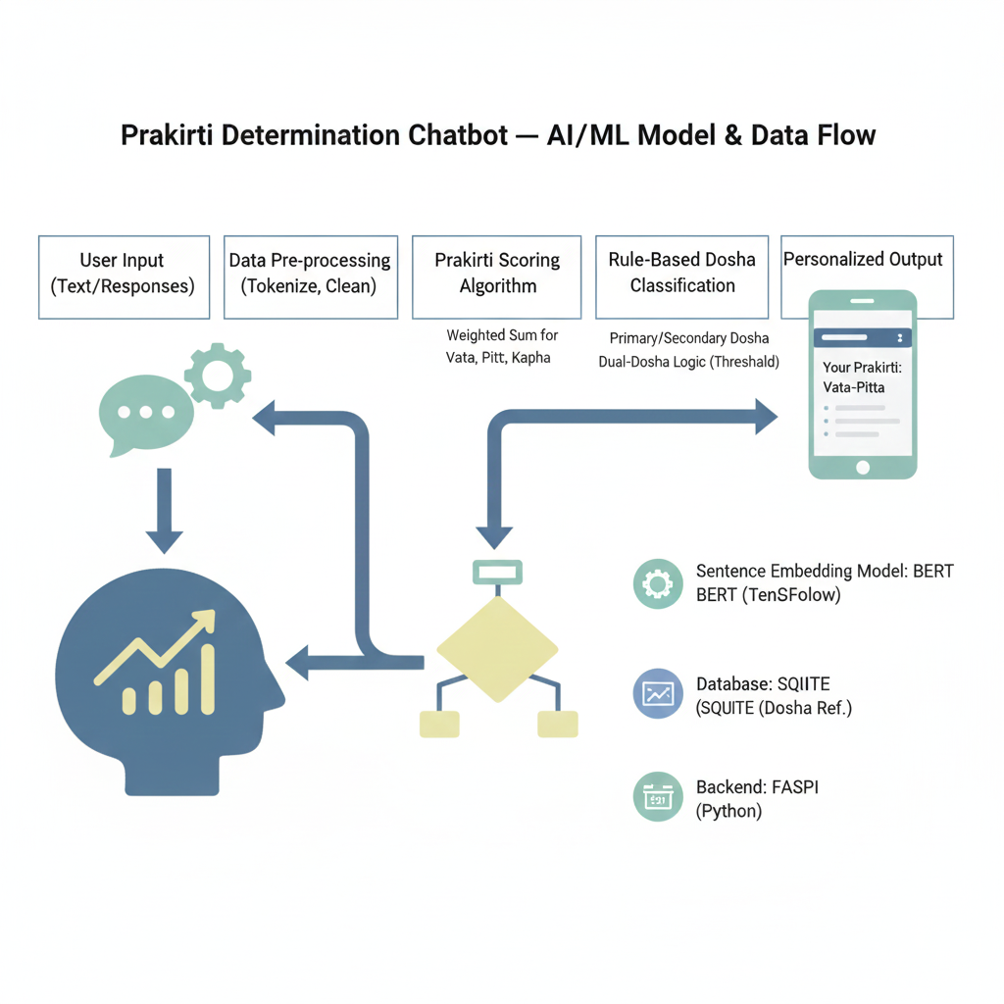

Fig :Prakriti determination chatbot

## **3 Software Stack and Development Environment**

* **Frontend:** HTML, CSS, JavaScript, Bootstrap
* **Backend:** Python 3.10, FastAPI
* **ML Framework:** TensorFlow / PyTorch (whichever you used)
* **Database:** SQLite / MySQL (your choice)
* **Hosting / Runtime:** Localhost or Cloud (if used)
* **Tools:** GitHub, VSCode, Postman

**4.Project Report – Plagiarism Report:**

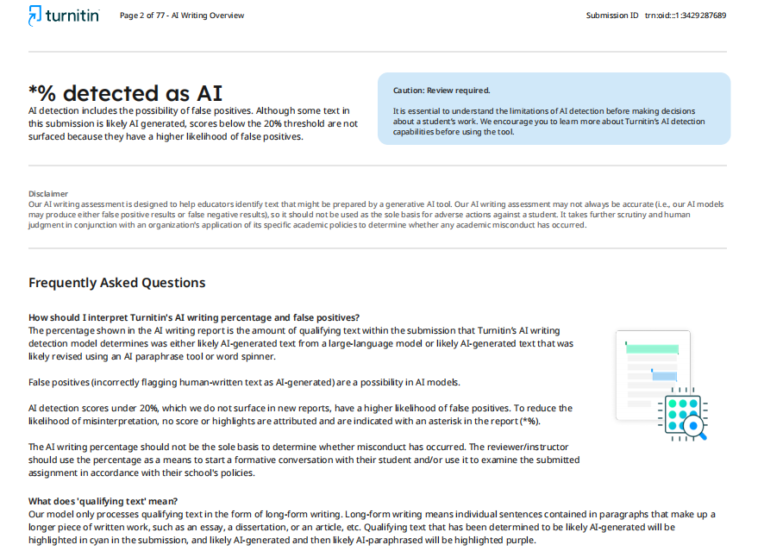

**5.Project Report - Similarity Report**:

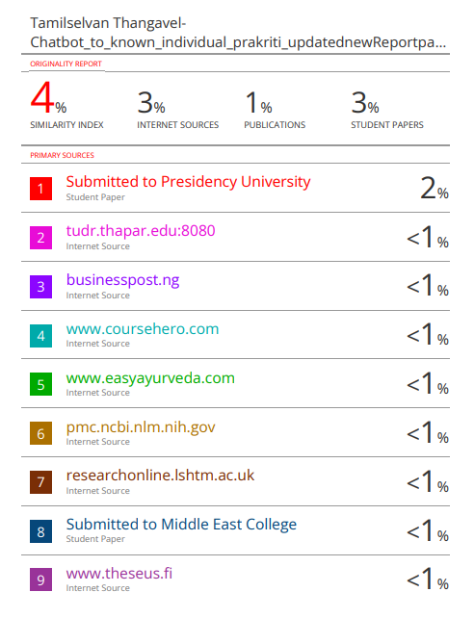

**6.Sample output:**

